The Holy Way Presbyterian Church

Tucson, Arizona

October 24, 2021 9:30 a.m.
Trusting In God Brings Comfort...

Welcome to Worship Rev. Tina Salvaneschi
Opening Prayer
Release Children to Sunday School - Miss Kathy
Introit: God of Grace and God of Glory (Hymn 307, Vs 3)
Ryan Phillips, Choir Director

Hymn: O Christ, The Healer (Hymn 793, Vs 1,2,3,5) Ryan Phillips, Choir Director

Call to Worship: Lay Leader, Joan Valenzuela
Loving, living God,
be among us now.
Show us your ways. Guide our steps.
Live in us, that we may be people of steadfast hope
and powerful giving.
Help us hear your words,
challenging us to give you
all the things that are yours.
Help us remember
that all we are and all we have
are gifts from you,
gifts to be shared in service and love.
Holy One among us,
help us be a holy people
who receive your word with joy
and live your message with love. Amen.

People: Amen

Birthdays and Anniversaries
Celebrations, Joys and Concerns Rev. Tina Salvaneschi
The People of the Congregation Share Joys and Concerns

...The Lord’s Prayer
People: Our Father, who art in heaven, hallowed be thy name. Thy kingdom come, thy will be done on earth as it is in heaven. Give us this day our daily bread, and forgive us our debts as we forgive our debtors. And lead us not into temptation, but deliver us from evil, for thine is the kingdom and the power and the glory forever. Amen

Anthem: Like As a Father Chancel Choir
Tithes and Offering: Prayer Rev. Tina Salvaneschi
(Option: Place you index card with a private prayer for Pastor)
(Option: write on index card a word or two what giving to God means to you-place index cards in plate)

Offertory Music: Dr. Astrid Chan

Scripture Reading: Lay Leader, Joan Valenzuela II Corinthians 3:9-18
9 For if the ministry of condemnation had glory, the ministry of righteousness exceeds much more in glory. 10 For even what was made glorious had no glory in this respect, because of the glory that excels. 11 For if what is passing away was glorious, what remains is much more glorious.

12 Therefore, since we have such hope, we use great boldness of speech— 13 unlike Moses, who put a veil over his face so that the children of Israel could not look steadily at the end of what was passing away. 14 But their minds were blinded. For until this day the same veil remains un lifted in the reading of the Old Testament, because the veil is taken away in Christ. 15 But even to this day, when Moses is read, a veil lies on their heart. 16 Nevertheless when one turns to the Lord, the veil is taken away. 17 Now the Lord is the Spirit; and where the Spirit of the Lord is, there is liberty. 18 But we all, with unveiled face, beholding as in a mirror the glory of the Lord, are being transformed into the same image from glory to glory, just as by the Spirit of the Lord.

Leader: This is the Word of the Lord. People: Thanks be to God.

Transformation: A Personal Journey by Kathy Walsh-Americano

Message: “Being Transformed by God’s Generous Heart”
Rev. Tina Salvaneschi

Sending Hymn: Know That God Is Good (Hymn #659, 1,2, Shona,1)
Ryan Phillips, Choir Director

Benediction: 2 Corinthians 13:14 Rev. Tina Salvaneschi
Song: Let There Be Peace on Earth Ryan Phillips, Choir Director Postlude: Dr. Astrid Chan

Stay Connected at The Holy Way
“Sermon Debrief Bible Study in person on Campus and Zoom” - Tuesday 10:00 a.m.
It’s Both! Come and meet live in the Conference Room at 10:00 a.m. or join on Zoom and we will conference you in on the big screen!
This is a great way to get to Fellowship, wrestle with questions about Sunday’s sermon, ponder the meaning of God’s Word, and discover how Scriptures can transform our lives today. This is led by Pastor Tina and is interactive! Come join the live class if you are able!

“Thoughtful Thursdays” - Thursday 10:00 a.m. Zoom Only
This is a great way to stay connected (especially for our snowbirds, and folks that can’t make it to in-person services!). We share about our lives, spend time talking, share joys, prayer requests…and anything else that comes up. Oh yes, laughter seems to happen too. This is group led, with Pastor Tina and for women AND men!

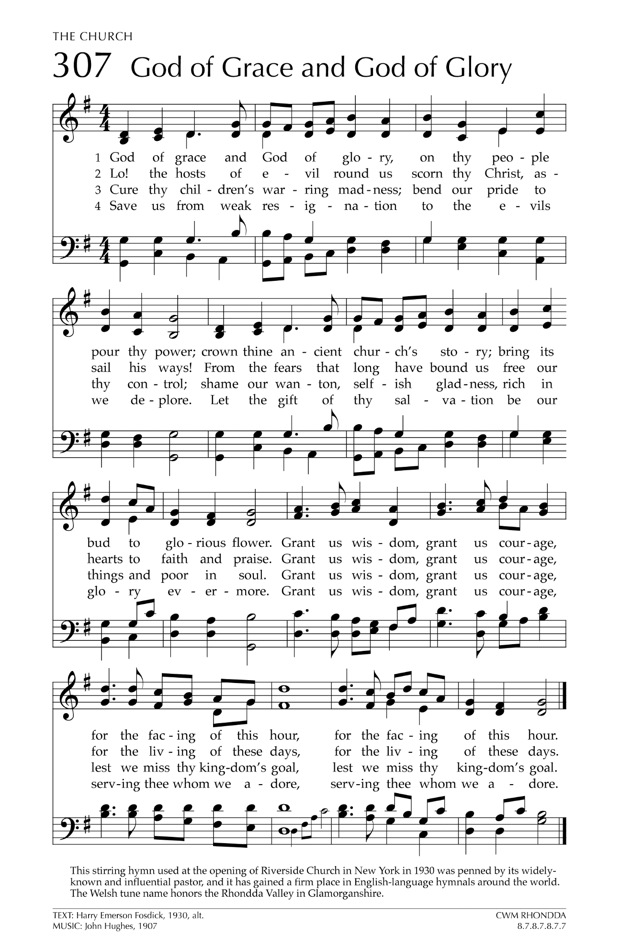
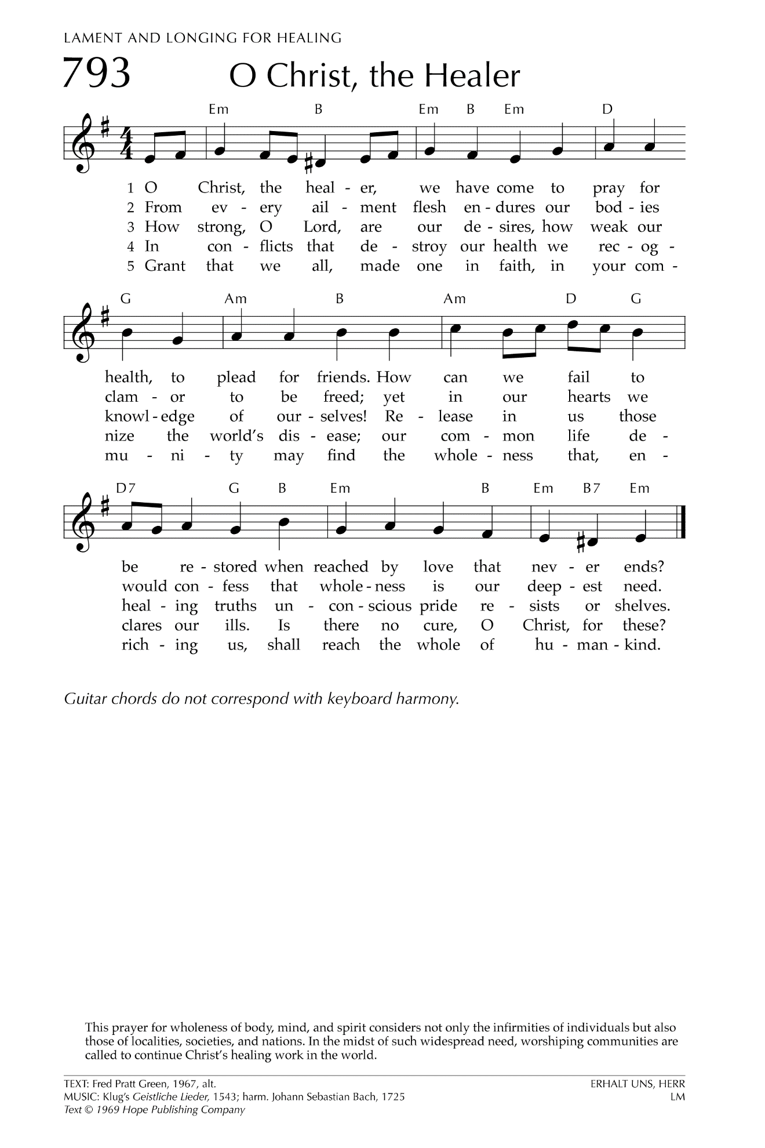
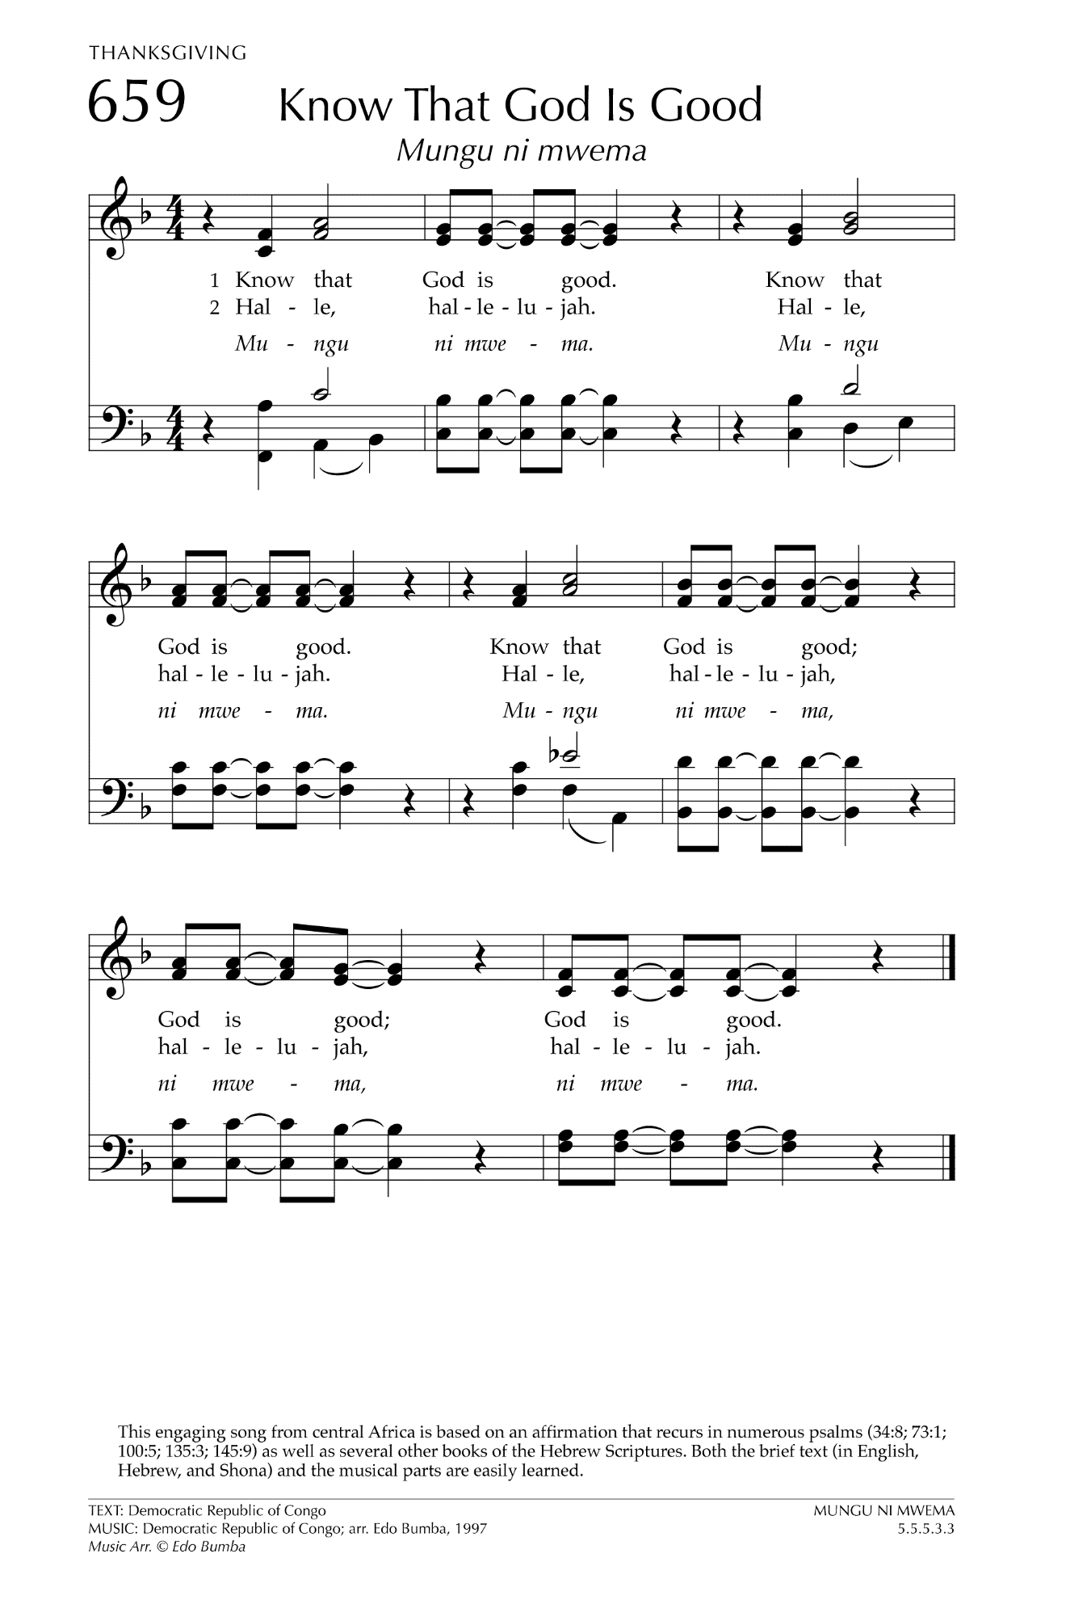

Let There Be Peace on Earth

Let there be peace on earth
And let it begin with me
Let there be peace on earth
The peace that was meant to be
With God as our Father
Christians all are we
Let us walk with each other
In perfect harmony.
Let peace begin with me
Let this be the moment now.
With every step I take
Let this be my solemn vow
To take each moment and live
Each moment in peace eternally
Let there be Peace on Earth
And let it begin with me!

