The Holy Way Presbyterian Church

Tucson, Arizona
June 27, 2021 9:30 a.m.
In The Beginning God Created…

Words of Meditation - The Lord made a promise to Humankind, and made covenants that only God-self can keep, by God’s own grace. Let us grow and learn together, and “Seek not to grow in knowledge chiefly for the sake of applause, and to enable you to dispute with others; but seek it for the benefit of your souls.” ― Jonathan Edwards

Welcome to Worship Rev. Tina Salvaneschi
Opening Prayer

Introit: Holy God, We Praise You Name (Hymn #4, V. 4)
Sinamar Pascua Respicio, Guest

Hymn: Where Cross The Crowded Way of Like (Hymn #343, V 1-4) Sinamar Pascua Respicio, Guest

Call to Worship: Lay Leader, Ruth Parsil
Now faith is the assurance of things hoped for,
the conviction of things not seen.
We come convinced of many things
but trusting very few.

Holy God of limitless surprises,
meet us here, in this place
as we touch that which we cannot see
that which we have not dared to hope

People: Amen

Prayers for the People Rev. Tina Salvaneschi
& The Lord’s Prayer

Our Father, who art in heaven, hallowed be thy name. Thy kingdom come, thy will be done on earth as it is in heaven. Give us this day our daily bread, and forgive us our debts as we forgive our debtors. And lead us not into temptation, but deliver us from evil, for thine is the kingdom and the power and the glory forever. Amen

Anthem: Take My Life and Let It Be Sinamar Pascua Respicio, Guest

Invitation for Tithes and Offering: Rev. Tina Salvaneschi

Offertory Music: Dr. Astrid Chan
(offering baskets available at all four exits as you leave)

Scripture Reading: Lay Leader, Ruth Parsil
Genesis 9:8-13, 18-29
8 Then God spoke to Noah and to his sons with him, saying: 9 “And as for Me, behold, I establish My covenant with you and with your [a]descendants after you, 10 and with every living creature that is with you: the birds, the cattle, and every beast of the earth with you, of all that go out of the ark, every beast of the earth. 11 Thus I establish My covenant with you: Never again shall all flesh be cut off by the waters of the flood; never again shall there be a flood to destroy the earth.”
12 And God said: “This is the sign of the covenant which I make between Me and you, and every living creature that is with you, for perpetual generations: 13 I set My rainbow in the cloud, and it shall be for the sign of the covenant between Me and the earth.
18 Now the sons of Noah who went out of the ark were Shem, Ham, and Japheth. And Ham was the father of Canaan. 19 These three were the sons of Noah, and from these the whole earth was populated.
20 And Noah began to be a farmer, and he planted a vineyard. 21 Then he drank of the wine and was drunk, and became uncovered in his tent. 22 And Ham, the father of Canaan, saw the nakedness of his father, and told his two brothers outside. 23 But Shem and Japheth took a garment, laid it on both their shoulders, and went backward and covered the nakedness of their father. Their faces were [b]turned away, and they did not see their father’s nakedness.
24 So Noah awoke from his wine, and knew what his younger son had done to him. 25 Then he said:
“Cursed be Canaan; A servant of servants He shall be to his brethren.” 26 And he said: “Blessed be the Lord, The God of Shem, And may Canaan be his servant.
27 May God enlarge Japheth, And may he dwell in the tents of Shem; And may Canaan be his servant.” 28 And Noah lived after the flood three hundred and fifty years. 29 So all the days of Noah were nine hundred and fifty years; and he died.
Leader: This is the Word of the Lord. People: Thanks be to God.

Message: Noah and His Sons Rev. Tina Salvaneschi

Sending Hymn: Great Is Thy Faithfulness (Hymn #39, V. 1,2, 3) Sinamar Pascua Respicio, Guest

Benediction: 2 Corinthians 13:14 Rev. Tina Salvaneschi

Song: Let There Be Peace On Earth Sinamar Pascua Respicio, Guest
Postlude: Dr. Astrid Chan

What’s New At the Holy Way?

“Sermon Debrief Bible Study” - Tuesday 10:00 a.m. Zoom
Come dive deeper into Sunday’s sermon and study the history, context, signs and meaning of God’s Word and how the Scriptures can apply to our lives today. This is lead by Pastor Tina and is very interactive!

“Thoughtful Thursdays” - Thursday 10:00 a.m. Zoom
This is a great way to stay connected (especially for our snowbirds, and folks that can’t make it to in-person services!). We share about our lives, spend time talking, share joys, pray requests…and anything else that comes up. Oh yes, laughter seems to happen too. This is group lead, with Pastor Tina and for women AND men!

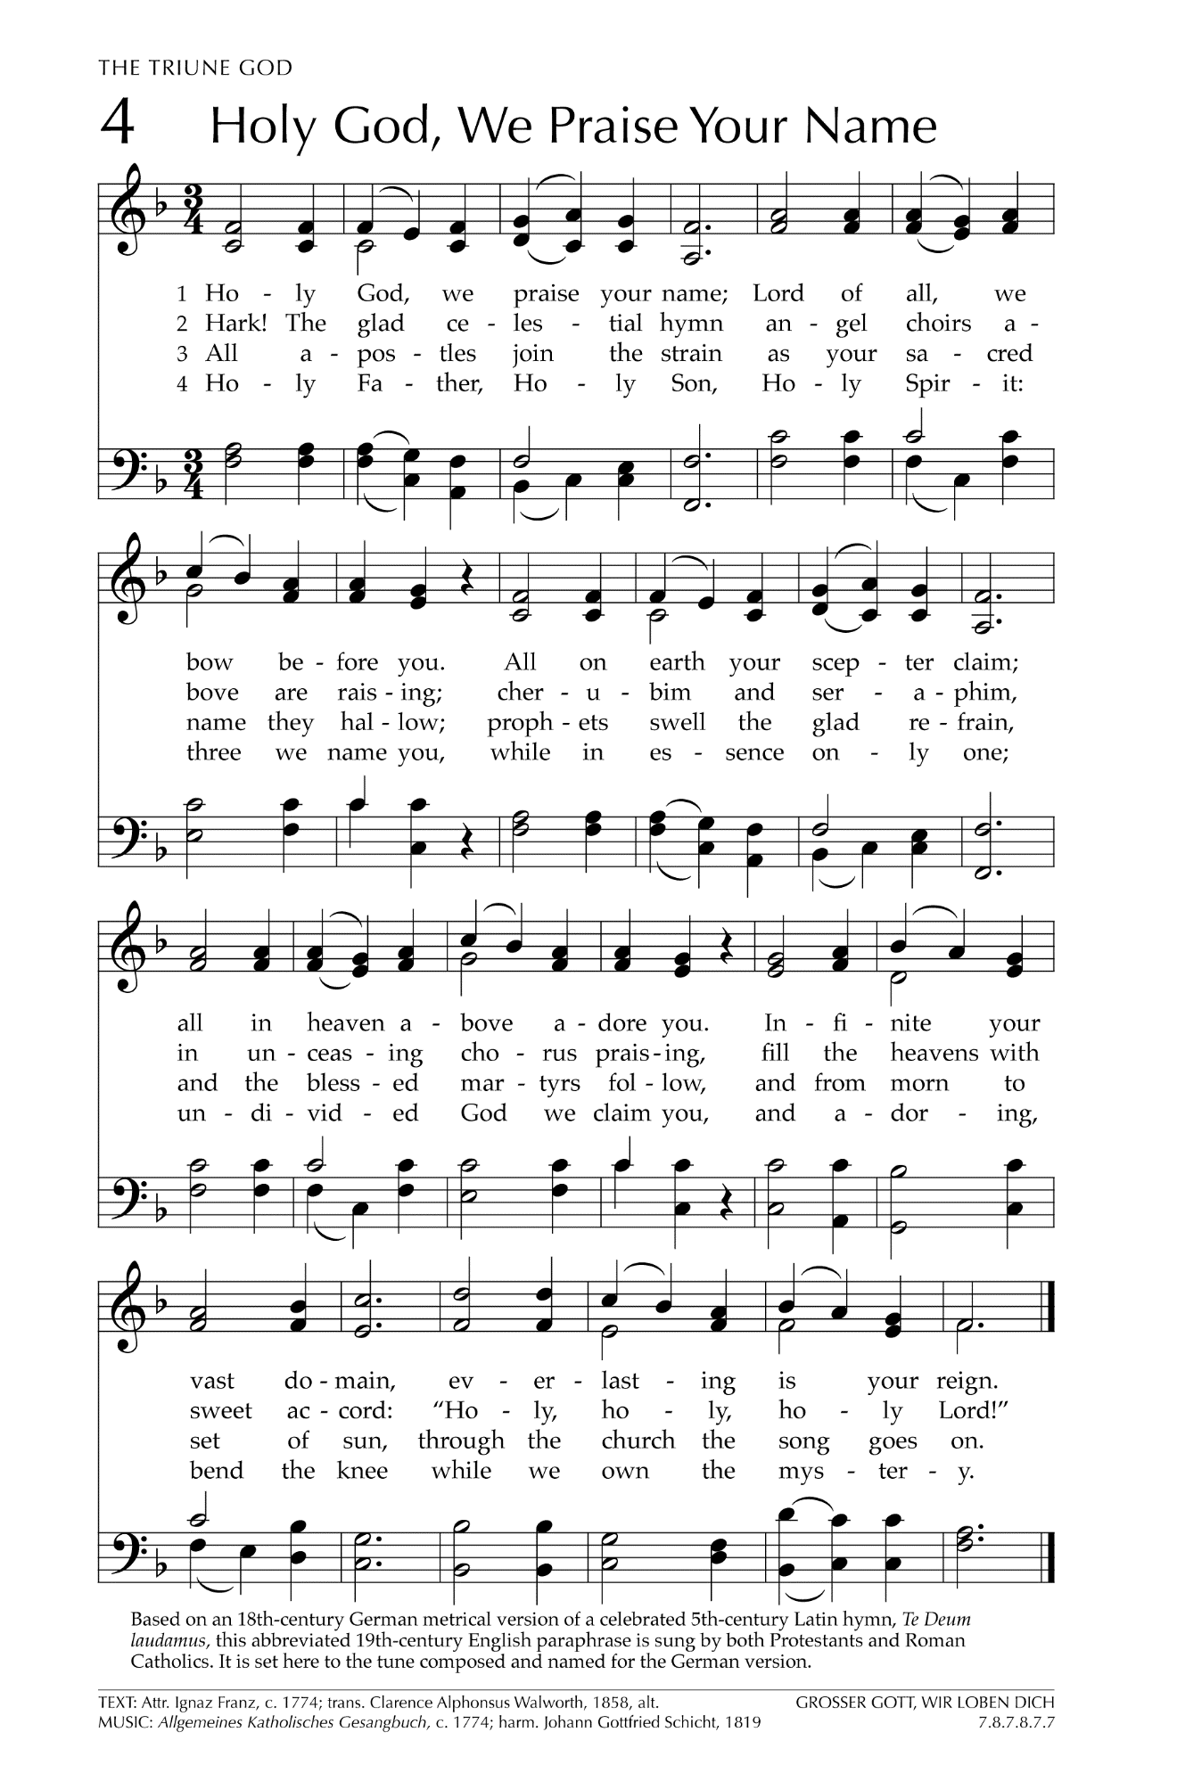
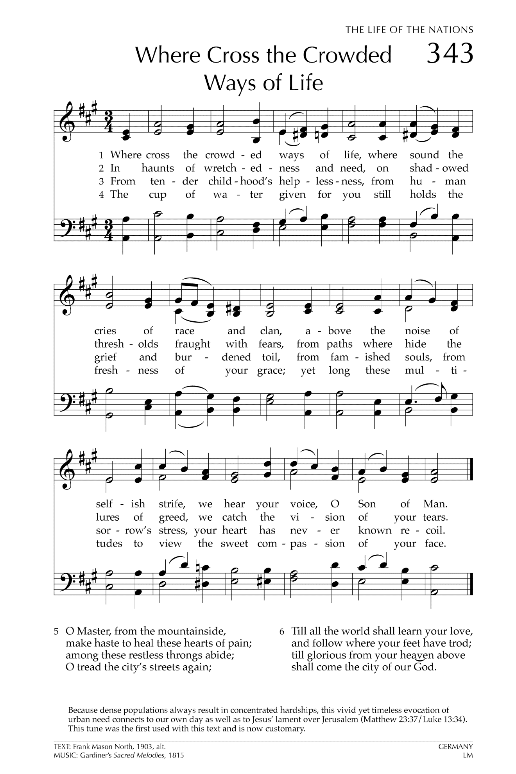
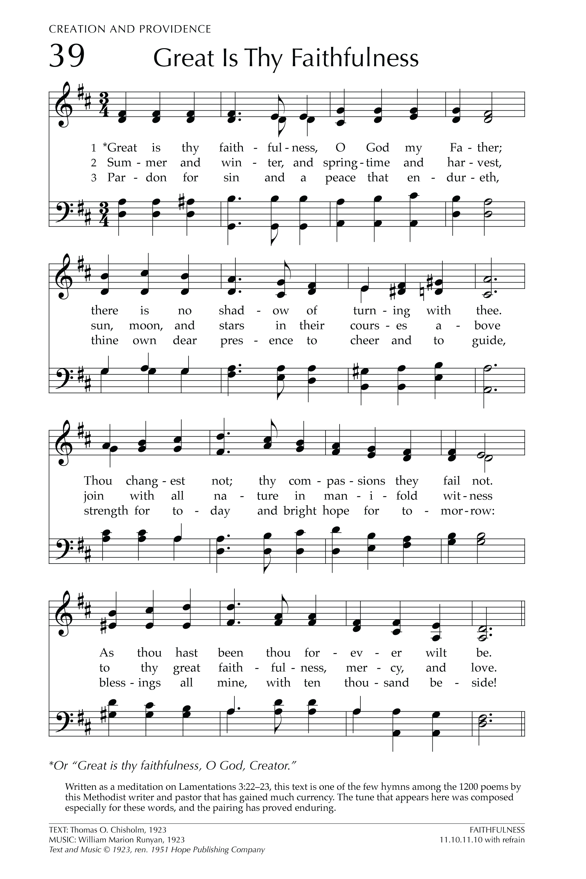
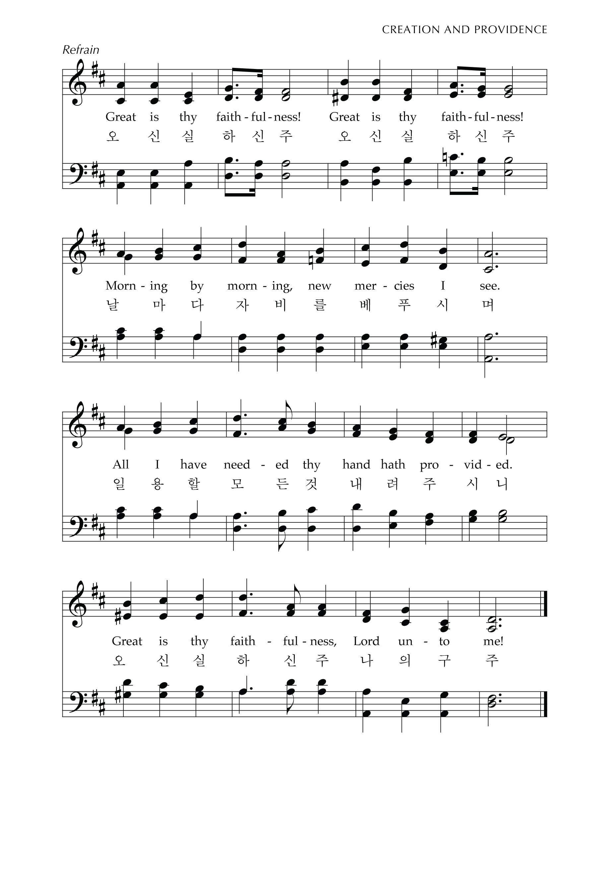

Let There Be Peace on Earth

Let there be peace on earth
And let it begin with me
Let there be peace on earth
The peace that was meant to be
With God as our Father
Christians all are we
Let us walk with each other
In perfect harmony.
Let peace begin with me
Let this be the moment now.
With every step I take
Let this be my solemn vow
To take each moment and live
Each moment in peace eternally
Let there be Peace on Earth
And let it begin with me!

