The Holy Way Presbyterian Church

Tucson, Arizona
July 11th, 2021 9:30 a.m.
Living In Community...

Words of Meditation - For by Grace we have been Saved...Words we often hear, but do we really understand what that means for us? God’s Grace, the Lord’s free gift to us is Grace, something that we cannot earn...no matter how good we are, or how many great things we do. It is God’s gift to give that we may be saved for eternal salvation.

Welcome to Worship Rev. Tina Salvaneschi
Ali Clay & Ginger Manly - Share about The Holy Way Food Bank
Opening Prayer

Introit: I Sing The Mighty Power of God (Hymn #32, V. 2)
Sinamar Pascua Respicio, Guest

Hymn: Restore In Us, O God (Hymn #434) Sinamar Pascua Respicio, Guest

Call to Worship: Lay Leader, Jeannie Hollis

Grace...
Even when we were dead,
Even when we turned away from the One who had created us.
Even when we lived in the grip of what drew our gaze from God.
Even when we were oblivious.
Even when we followed a path fashioned
of nothing but our own desires.
Even when we wandered far and willfully away.
Even when we forgot to look past our own feet to see
the wonders not of our making.
Even when we failed to stand in awe, to breathe thanks,
to lean into the love that had waited long for us.
Even when, Even when,
even then:
There was Grace.

People: Amen

Birthdays and Anniversaries Rev. Tina Salvaneschi
Celebrations, Joys and Concerns
The People of the Congregation Share

...The Lord’s Prayer
People: Our Father, who art in heaven, hallowed be thy name. Thy kingdom come, thy will be done on earth as it is in heaven. Give us this day our daily bread, and forgive us our debts as we forgive our debtors. And lead us not into temptation, but deliver us from evil, for thine is the kingdom and the power and the glory forever. Amen

Anthem: The Light of A Million Mornings
Sinamar Pascua Respicio, Guest

Invitation for Tithes and Offering: Rev. Tina Salvaneschi

Offertory Music: Dr. Astrid Chan
(offering baskets available at all four exits as you leave)

Scripture Reading: Lay Leader, Jeannie Hollis
Ephesians 2:1-10
2 And you He made alive, who were dead in trespasses and sins, 2 in which you once walked according to the [a]course of this world, according to the prince of the power of the air, the spirit who now works in the sons of disobedience, 3 among whom also we all once conducted ourselves in the lusts of our flesh, fulfilling the desires of the flesh and of the mind, and were by nature children of wrath, just as the others.
4 But God, who is rich in mercy, because of His great love with which He loved us, 5 even when we were dead in trespasses, made us alive together with Christ (by grace you have been saved), 6 and raised us up together, and made us sit together in the heavenly places in Christ Jesus, 7 that in the ages to come He might show the exceeding riches of His grace in His kindness toward us in Christ Jesus. 8 For by grace you have been saved through faith, and that not of yourselves; it is the gift of God, 9 not of works, lest anyone should boast. 10 For we are His workmanship, created in Christ Jesus for good works, which God prepared beforehand that we should walk in them.

Leader: This is the Word of the Lord. People: Thanks be to God.

Message: From Death To Life Rev. Tina Salvaneschi

Sending Hymn: We Will Go Out with Joy (Hymn #539)
Sinamar Pascua Respicio, Guest

Benediction: 2 Corinthians 13:14 Rev. Tina Salvaneschi

Song: Let There Be Peace On Earth
Sinamar Pascua Respicio, Guest
Postlude: Dr. Astrid Chan

What’s New at The Holy Way

“Sermon Debrief Bible Study” in person on Campus and Zoom -Tuesday 10:00 a.m.!
It’s Both! Come and meet live in the Conference Room at 10:00 a.m. or join on Zoom and we will conference you in on the big screen!
We are starting our new series called “Living In Community” in the book of Ephesians so don’t miss out! This is a great way to get to know the Holy Way Folks and dive deeper into Sunday’s sermon, ask questions, ponder the meaning of God’s Word and discover how the Holy Scriptures can apply to our lives today. This is led by Pastor Tina and is very interactive! Come join the live class if you are fully vaccinated!

“Thoughtful Thursdays” - Thursdays 10:00 a.m. Zoom Only (for now...)
This is a great way to stay connected (especially for our snowbirds, and folks that can’t make it to in-person services!). We share about our lives, spend time talking, share joys, prayer requests…and anything else that comes up. Oh yes, laughter seems to happen too. This is group led, with Pastor Tina and for women AND men!

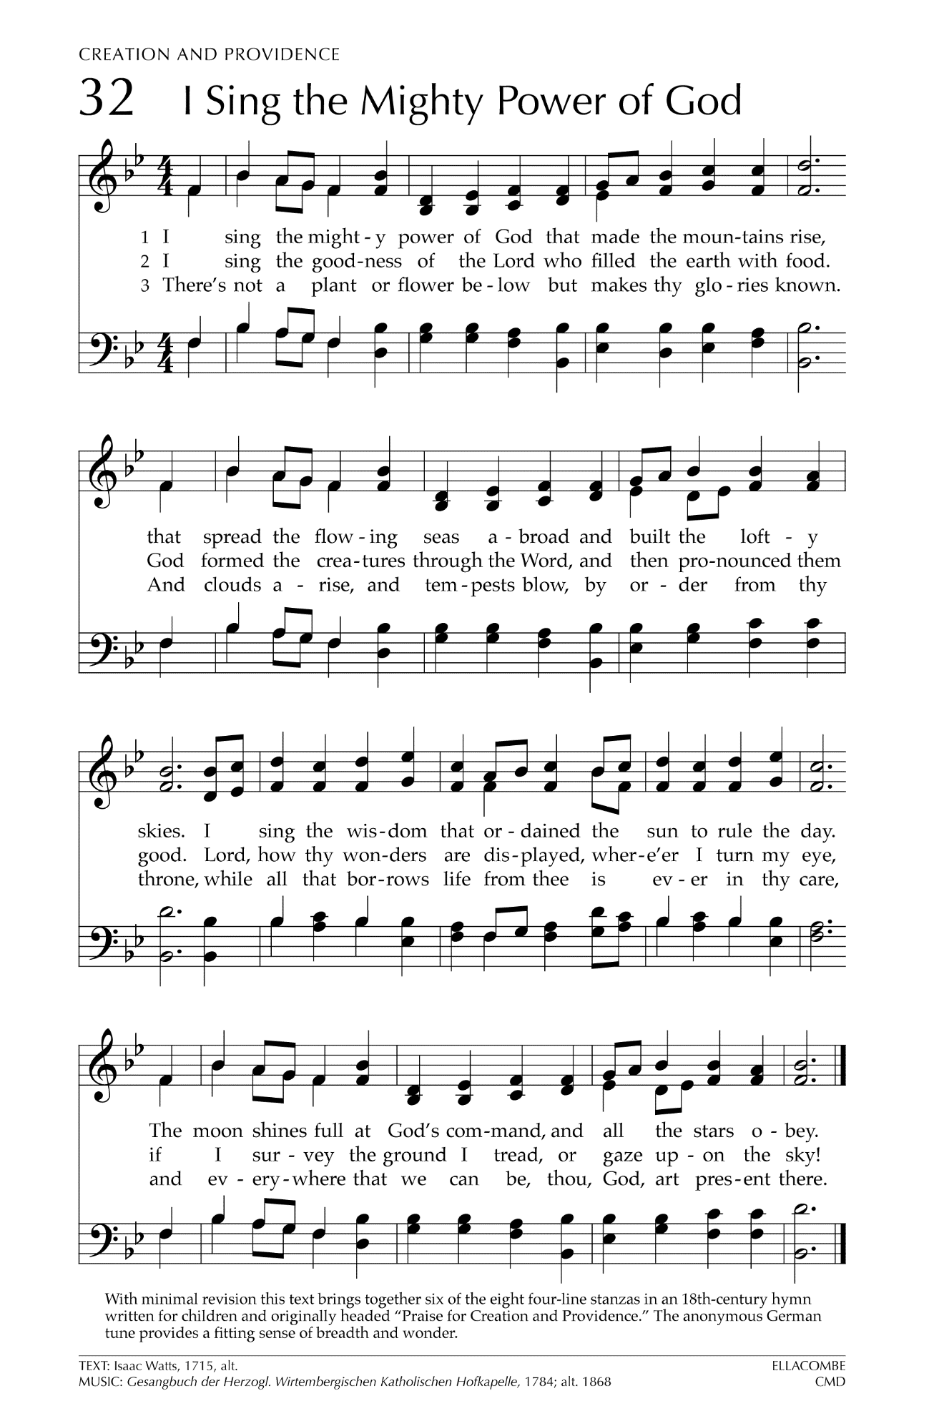

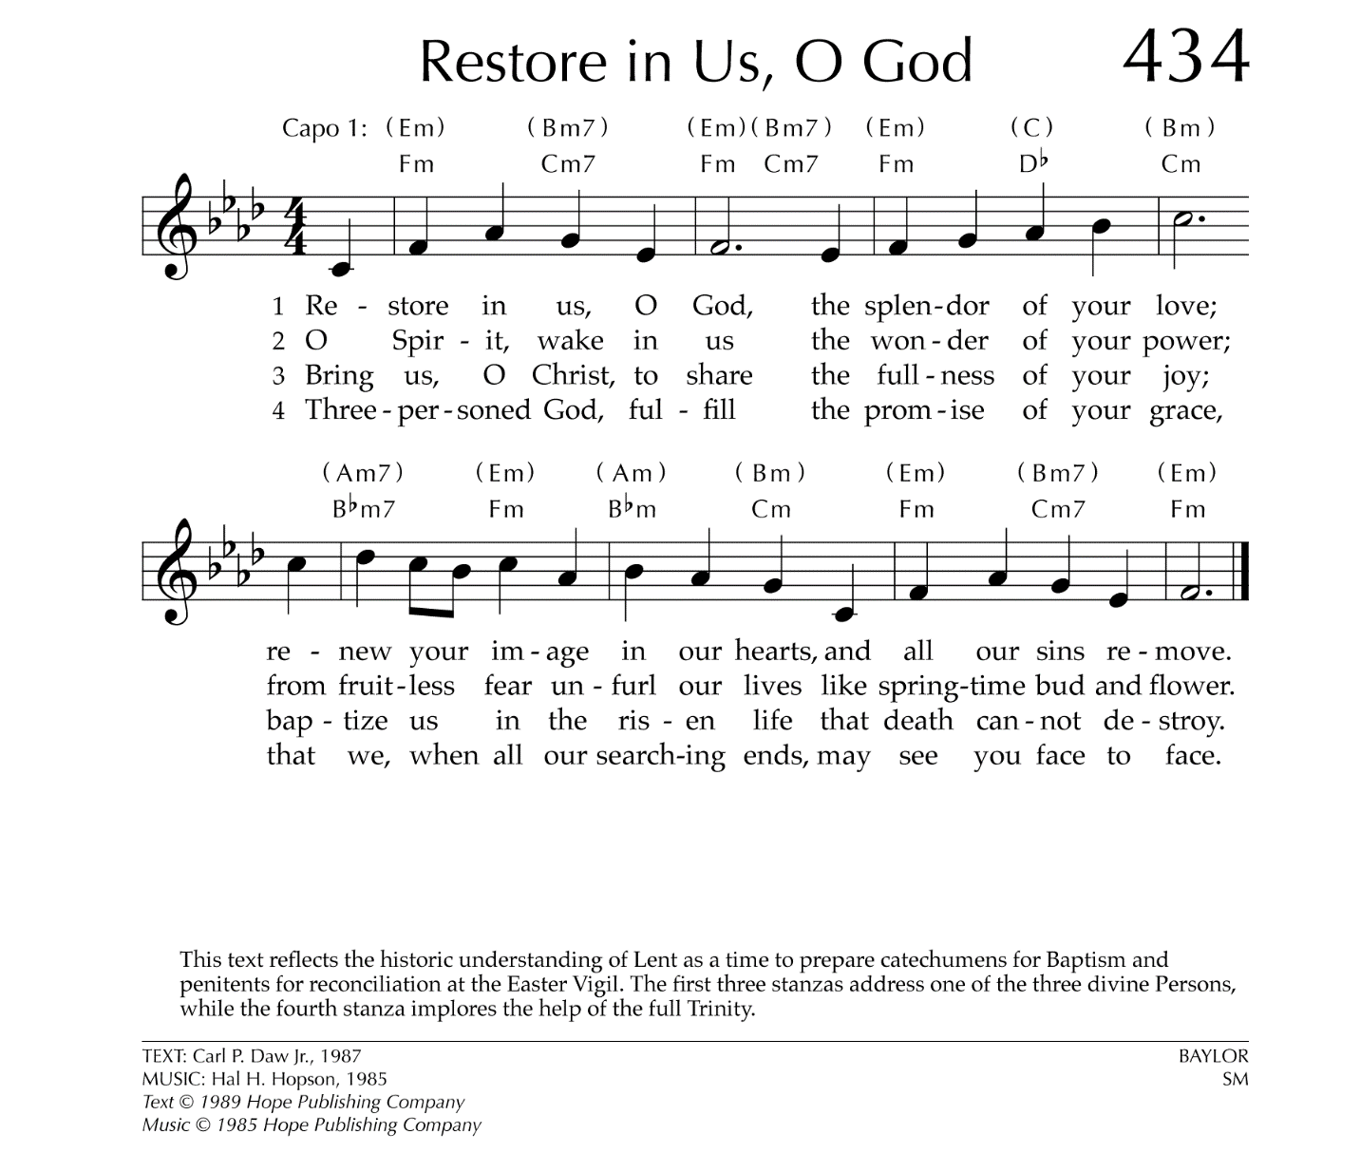

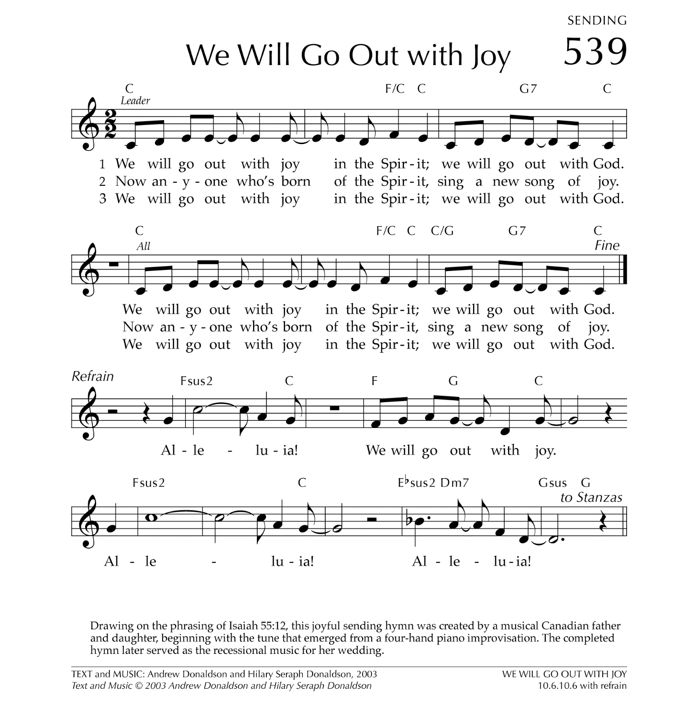

Let There Be Peace on Earth

Let there be peace on earth
And let it begin with me
Let there be peace on earth
The peace that was meant to be
With God as our Father
Christians all are we
Let us walk with each other
In perfect harmony.
Let peace begin with me
Let this be the moment now.
With every step I take
Let this be my solemn vow
To take each moment and live
Each moment in peace eternally
Let there be Peace on Earth
And let it begin with me!

