The Holy Way Presbyterian Church
Tucson, Arizona

December 26, 2021 9:30 a.m.
First Sunday After Christmas…
Welcome to Worship Rev. Tina Salvaneschi
Opening Prayer
Release Children to Sunday School

Hymn: What Child Is This (Hymn #145) Congregation
Call To Worship: Lay Leader, Ali Clay
Let us praise the name of the Lord!
God commanded and we were created.
Leaders and followers,
old and young,
all of God’s beloved children,
all people everywhere as with the angels,
let us come and praise the exalted name of the Lord.
Let us worship God

O God,
into a realm of clerics and kings
you sent your child
to teach the wise and show the world
what power there is in love.
Keep us vigilant
to hear the voices
of those who speak your truth.
In the name of Jesus we pray.

People: Amen

Birthdays and Anniversaries Soren Perry
If you want to participate in our tradition of celebrating your birthday or anniversary by giving money towards church building, renovations, improvements & sound systems, just waive your hand, or stand up and Pastor Tina will receive it in the plate!

Celebrations, Joys and Concerns Rev. Tina Salvaneschi
The People of the Congregation Share Joys and Concerns
Soren will bring the microphone to you.

The Lord’s Prayer
People: Our Father, who art in heaven, hallowed be thy name. Thy kingdom come, thy will be done on earth as it is in heaven. Give us this day our daily bread, and forgive us our debts as we forgive our debtors. And lead us not into temptation, but deliver us from evil, for thine is the kingdom and the power and the glory forever. Amen

Anthem: Special Music Guest Vocalist
Tithes and Offering: Prayer Rev. Tina Salvaneschi
(Option: Place you index card with a private prayer for Pastor)
(Option: write on index card a word or two what giving to God means to you place index cards in plate)

Offertory Music: Go Tell It On The Mountain The Quintet

Doxology: (Hymn #606) Congregation
Praise God, from whom all blessings flow;
praise Him all creatures here below;
praise God above, ye heavenly host;
praise Father, Son, and Holy Ghost. Amen.

Scripture Reading: Lay Leader, Ali Clay
Isaiah 60-1-8

Arise, shine;
For your light has come!
And the glory of the Lord is risen upon you.
2 For behold, the darkness shall cover the earth,
And deep darkness the people;
But the Lord will arise over you,
And His glory will be seen upon you.
3 The Gentiles shall come to your light,
And kings to the brightness of your rising.

4 “Lift up your eyes all around, and see:
They all gather together, they come to you;
Your sons shall come from afar,
And your daughters shall be nursed at your side.

5 Then you shall see and become radiant,
And your heart shall swell with joy;
Because the abundance of the sea shall be turned to you,
The wealth of the Gentiles shall come to you.
6 The multitude of camels shall cover your land,
The dromedaries of Midian and Ephah;
All those from Sheba shall come;
They shall bring gold and incense,
And they shall proclaim the praises of the Lord.
7 All the flocks of Kedar shall be gathered together to you,
The rams of Nebaioth shall minister to you;
They shall ascend with acceptance on My altar,
And I will glorify the house of My glory.

8 “Who are these who fly like a cloud,
And like doves to their roosts?

Leader: This is the Word of the Lord.
People: Thanks be to God.

Message: “The Epiphany” Rev. Tina Salvaneschi

Sending Hymn: Angels We Have Heard On High (Hymn #113)
Congregation
Benediction: 2 Corinthians 13:14 Rev. Tina Salvaneschi
Song: Let There Be Peace on Earth Congregation
Postlude: Dr. Astrid Chan

Sermon Debrief and Thoughtful Thursdays will be closed for the Holidays during the next two weeks!
We will resume our gatherings on Tuesday January 11th!

Stay Connected During the Week!

“Sermon Debrief Bible Study in person on Campus” - Tuesday 10:00 am! Vaccinated Only Please (no Zoom)
Come and meet live in the Sanctuary at 10:00 am.
This is a great way to get to Fellowship, wrestle with questions about Sunday’s sermon, ponder the meaning of God’s Word, and discover how Scriptures can transform our lives today. This is led by Pastor Tina and is interactive and often there are donuts! Come join the live class if you are able!
“Thoughtful Thursdays” - Thursdays 10:00 am Zoom Only
This is a great way to stay connected (especially for our snowbirds, and folks that can’t make it to in-person services!). We share about our lives, spend time talking, share joys, pray requests…and anything else that comes up. Oh yes, laughter seems to happen too. This is group led, with Pastor Tina and for women AND men!
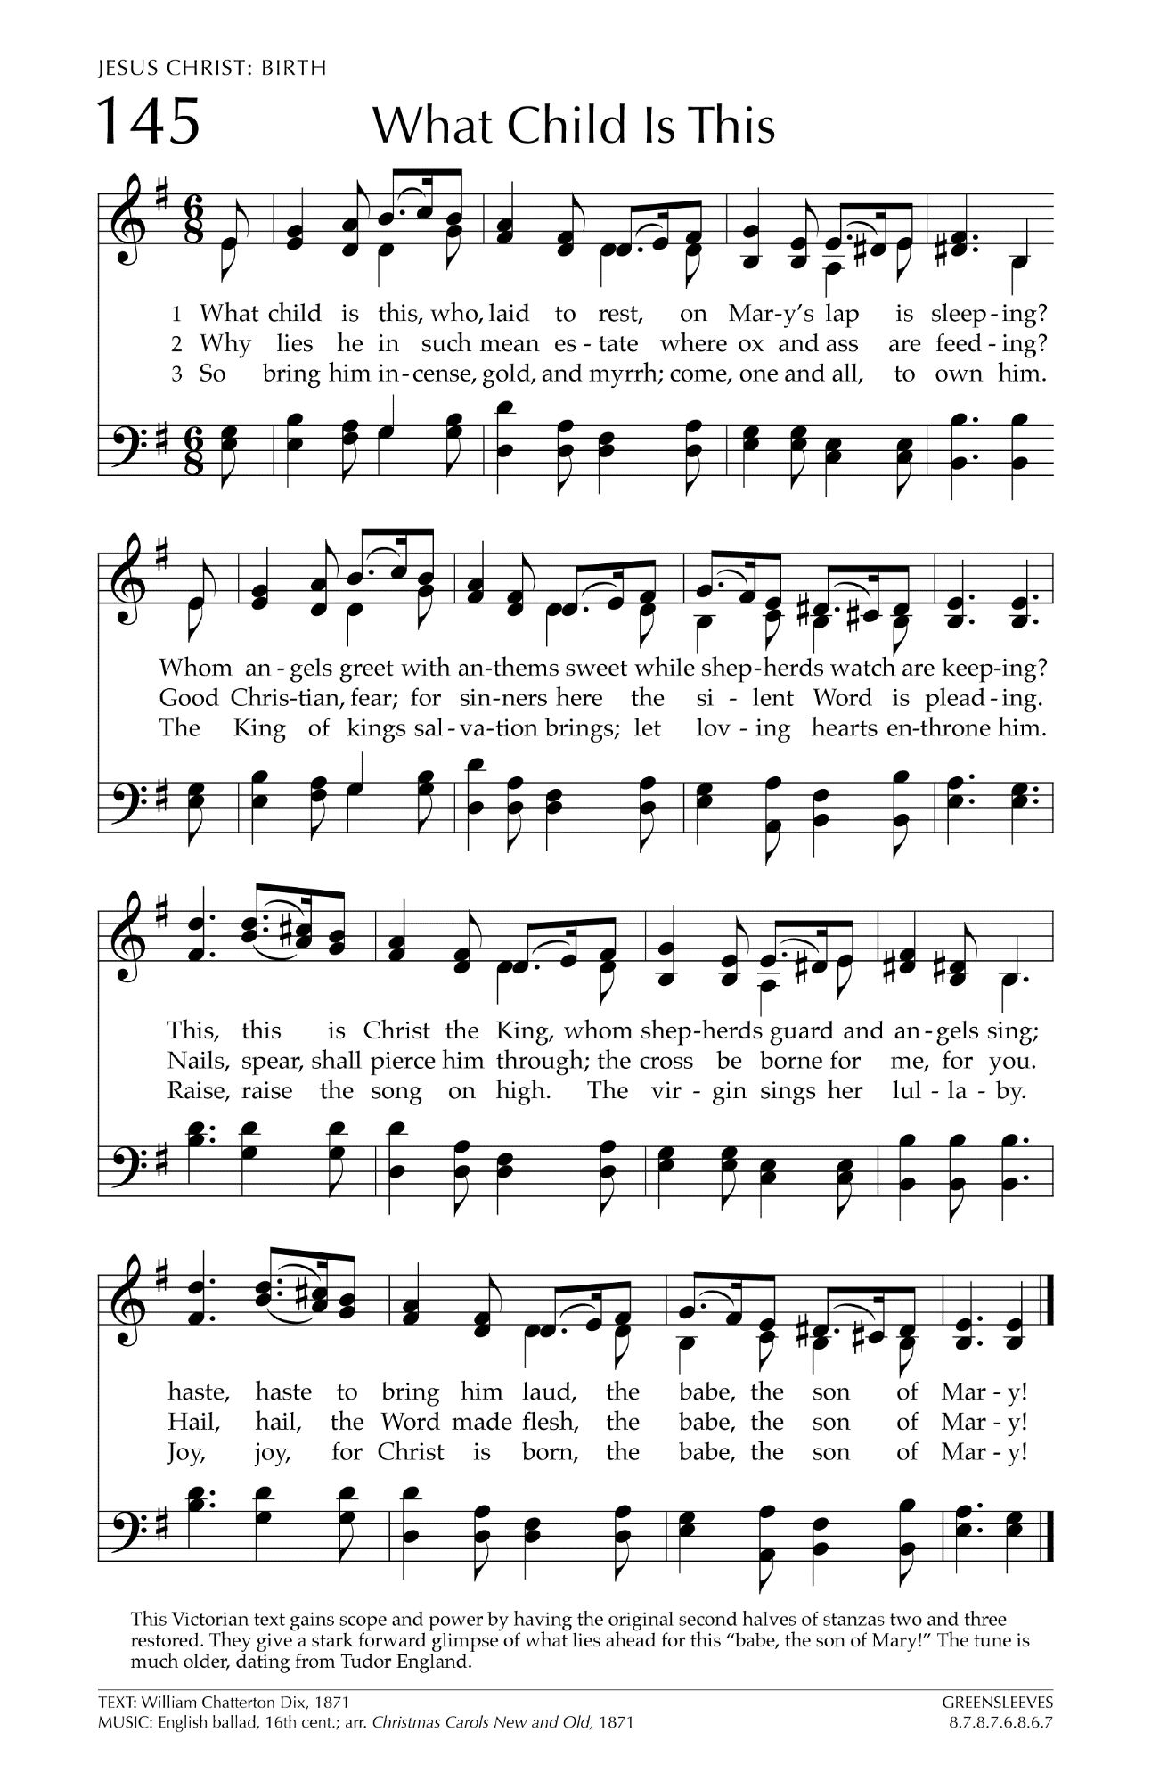
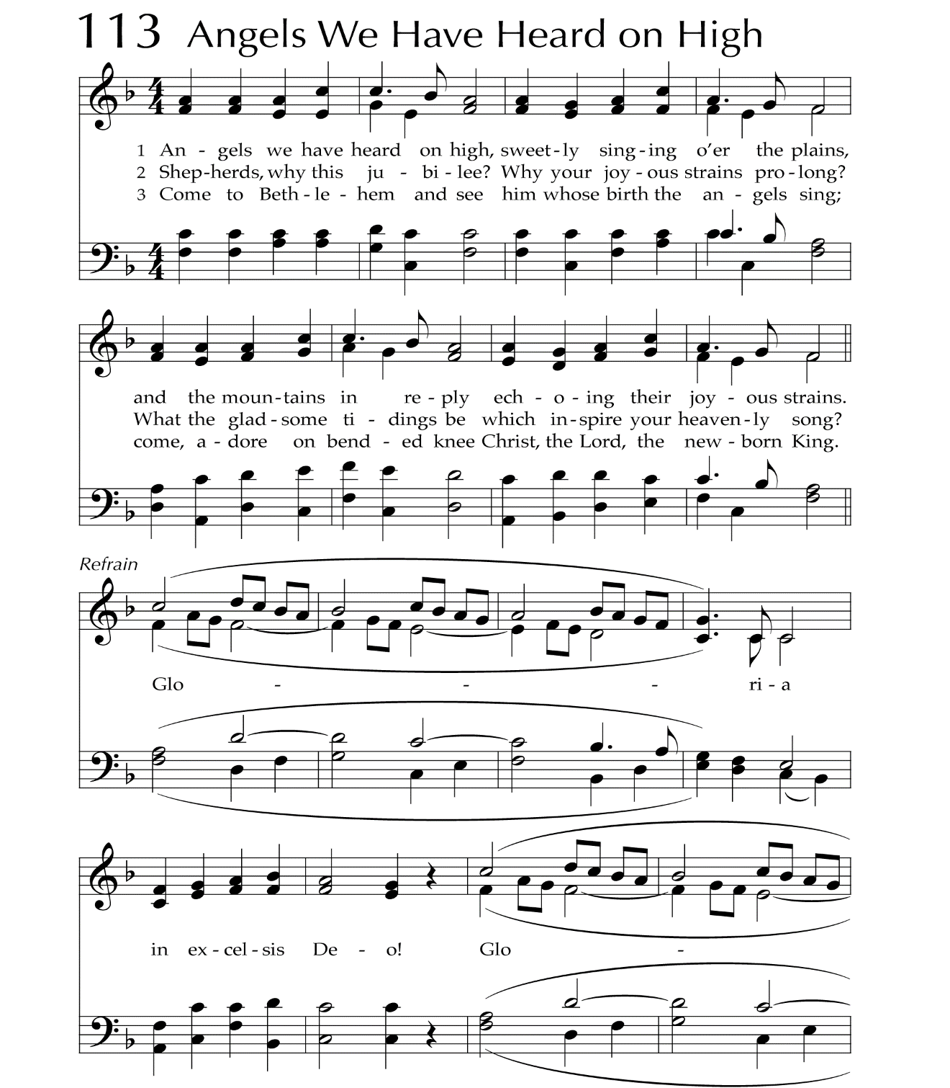
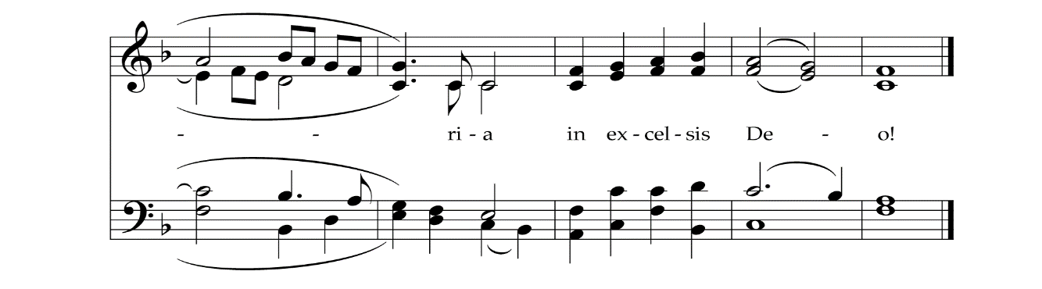

Let There Be Peace on Earth

Let there be peace on earth
And let it begin with me
Let there be peace on earth
The peace that was meant to be
With God as our Father
Christians all are we
Let us walk with each other
In perfect harmony.
Let peace begin with me
Let this be the moment now.
With every step I take
Let this be my solemn vow
To take each moment and live
Each moment in peace eternally
Let there be Peace on Earth
And let it begin with me!

