The Holy Way Presbyterian Church
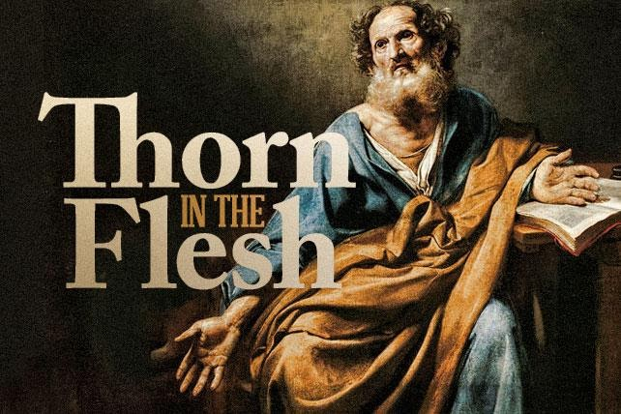

Tucson, Arizona

November 21, 2021 9:30 a.m.
Trusting In God Brings Comfort...

Welcome to Worship Rev. Tina Salvaneschi
Opening Prayer
Release Children to Sunday School - Miss Kathy
Introit: Glorious Things of Thee are Spoken (Hymn #81, vs3)
Ryan Phillips, Choir Director

Hymn: Lord of All Hopefulness (Hymn #683) Ryan Phillips, Choir Director

Installation of New Members: Rev. Tina Salvaneschi

Birthdays and Anniversaries Stephen Levine
If you want to participate in our tradition of celebrating your birthday or anniversary by giving money towards church building, renovation, improvements, and sound systems, just waive your hand, or stand up and Pastor Tina will receive it in the plate!

Celebrations, Joys and Concerns Rev. Tina Salvaneschi
The People of the Congregation Share Joys and Concerns

...The Lord’s Prayer
People: Our Father, who art in heaven, hallowed be thy name. Thy kingdom come, thy will be done on earth as it is in heaven. Give us this day our daily bread, and forgive us our debts as we forgive our debtors. And lead us not into temptation, but deliver us from evil, for thine is the kingdom and the power and the glory forever. Amen

Anthem: The Gift of Love Chancel Choir
Though I may speak with bravest fire, and have the gift to all inspire,
And have not love; my words are vain, as sounding brass, and hopeless gain.
Though I may give all I possess, and striving so my love profess,
But not be giv’n by love within, the profit soon turns strangely thin.
Come, spirit come, our hearts control, Our spirits long to be made whole.
O come, spirit, come
Let inward love guide ev’ry deed. By this we worship and are freed.
Amen. Amen. Amen.

Tithes and Offering: Prayer Rev. Tina Salvaneschi
(Option: Place you index card with a private prayer for Pastor)
(Option: write on index card a word or two what giving to God means to you place index cards in plate)

Offertory Music: Dr. Astrid Chan

Doxology: (Hymn #606) Ryan Phillips, Choir Director
Praise God, from whom all blessings flow;
praise God all creatures here below;
praise God above, ye heavenly host;
praise Father, Son, and Holy Ghost. Amen.

Scripture Reading: Lay Leader, Cindy Johnston
II Corinthians 12:1-10

1 I must go on boasting. Although there is nothing to be gained, I will go on to visions and revelations from the Lord. 2 I know a man in Christ who fourteen years ago was caught up to the third heaven. Whether it was in the body or out of the body I do not know—God knows. 3 And I know that this man—whether in the body or apart from the body I do not know, but God knows— 4 was caught up to paradise and heard inexpressible things, things that no one is permitted to tell.

5 I will boast about a man like that, but I will not boast about myself, except about my weaknesses. 6 Even if I should choose to boast, I would not be a fool, because I would be speaking the truth. But I refrain, so no one will think more of me than is warranted by what I do or say, 7 or because of these surpassingly great revelations.

Therefore, in order to keep me from becoming conceited, I was given a thorn in my flesh, a messenger of Satan, to torment me. 8 Three times I pleaded with the Lord to take it away from me. 9 But he said to me, “My grace is sufficient for you, for my power is made perfect in weakness.” Therefore I will boast all the more gladly about my weaknesses, so that Christ’s power may rest on me. 10 That is why, for Christ’s sake, I delight in weaknesses, in insults, in hardships, in persecutions, in difficulties. For when I am weak, then I am strong.

Leader: This is the Word of the Lord.

People: Thanks be to God.

Message: “The Thorn in The Flesh” Rev. Tina Salvaneschi

Sending Hymn: There is Now A New Creation (Hymn #774)
Ryan Phillips, Choir Director

Benediction: 2 Corinthians 13:14 Rev. Tina Salvaneschi

Song: Let There Be Peace on Earth Ryan Phillips, Choir Director
Postlude: Dr. Astrid Chan

Stay Connected at The Holy Way
“Sermon Debrief Bible Study in person on Campus” - Tuesday 10:00 a.m! Vaccinated Only Please (no Zoom)
Come and meet live in the Sanctuary at 10:00 a.m.
This is a great way to get to Fellowship, wrestle with questions about Sunday’s sermon, ponder the meaning of God’s Word, and discover how Scriptures can transform our lives today. This is led by Pastor Tina and is interactive! Come join the live class if you are able!

“Thoughtful Thursdays” - Thursday 10:00 a.m. Zoom Only
This is a great way to stay connected (especially for our snowbirds, and folks that can’t make it to in-person services!). We share about our lives, spend time talking, share joys, prayer requests…and anything else that comes up. Oh yes, laughter seems to happen too. This is group led, with Pastor Tina and for women AND men!

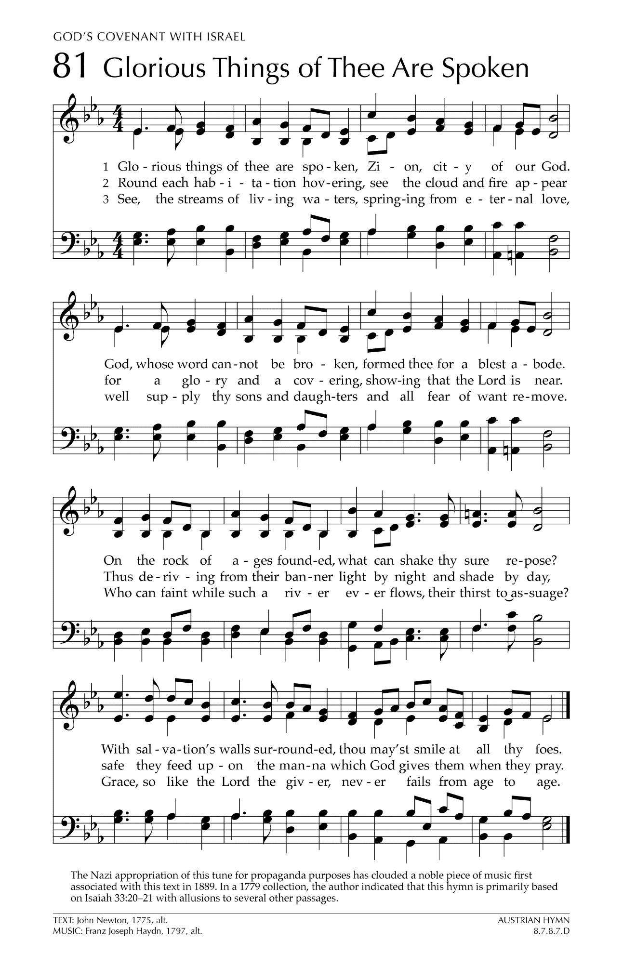
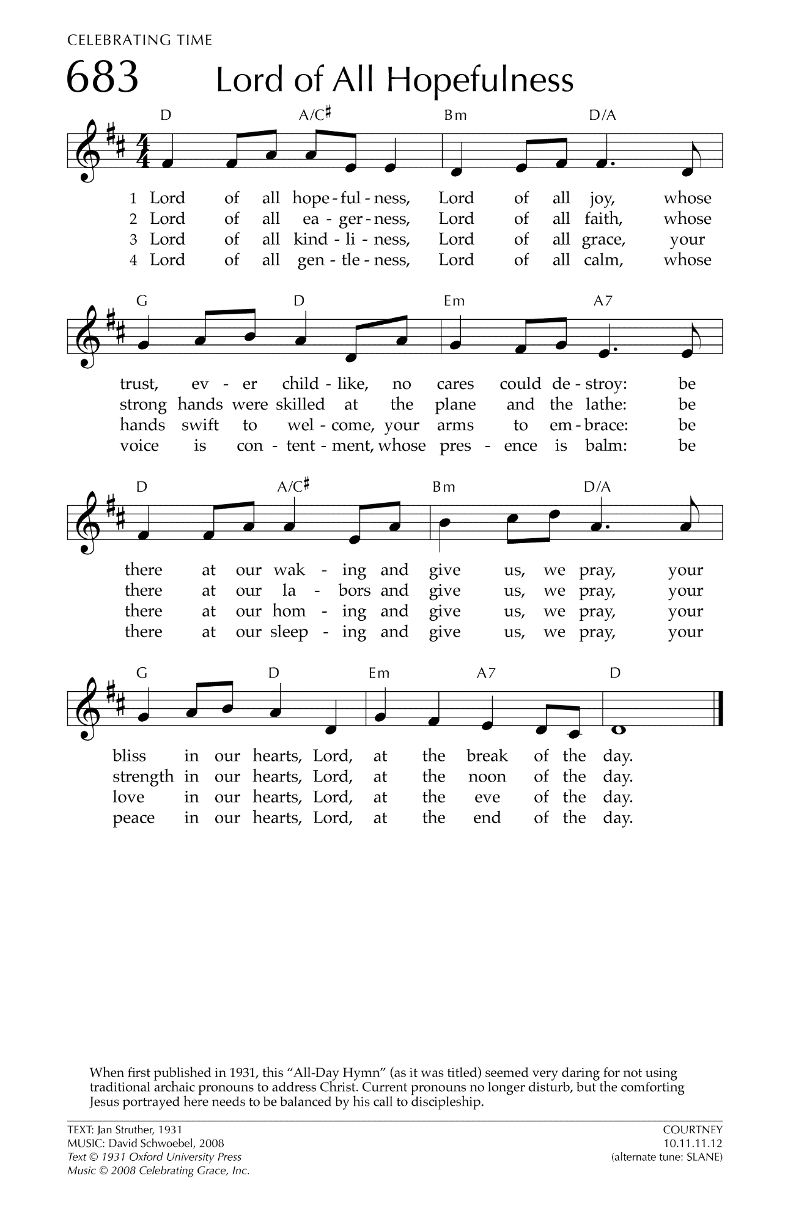
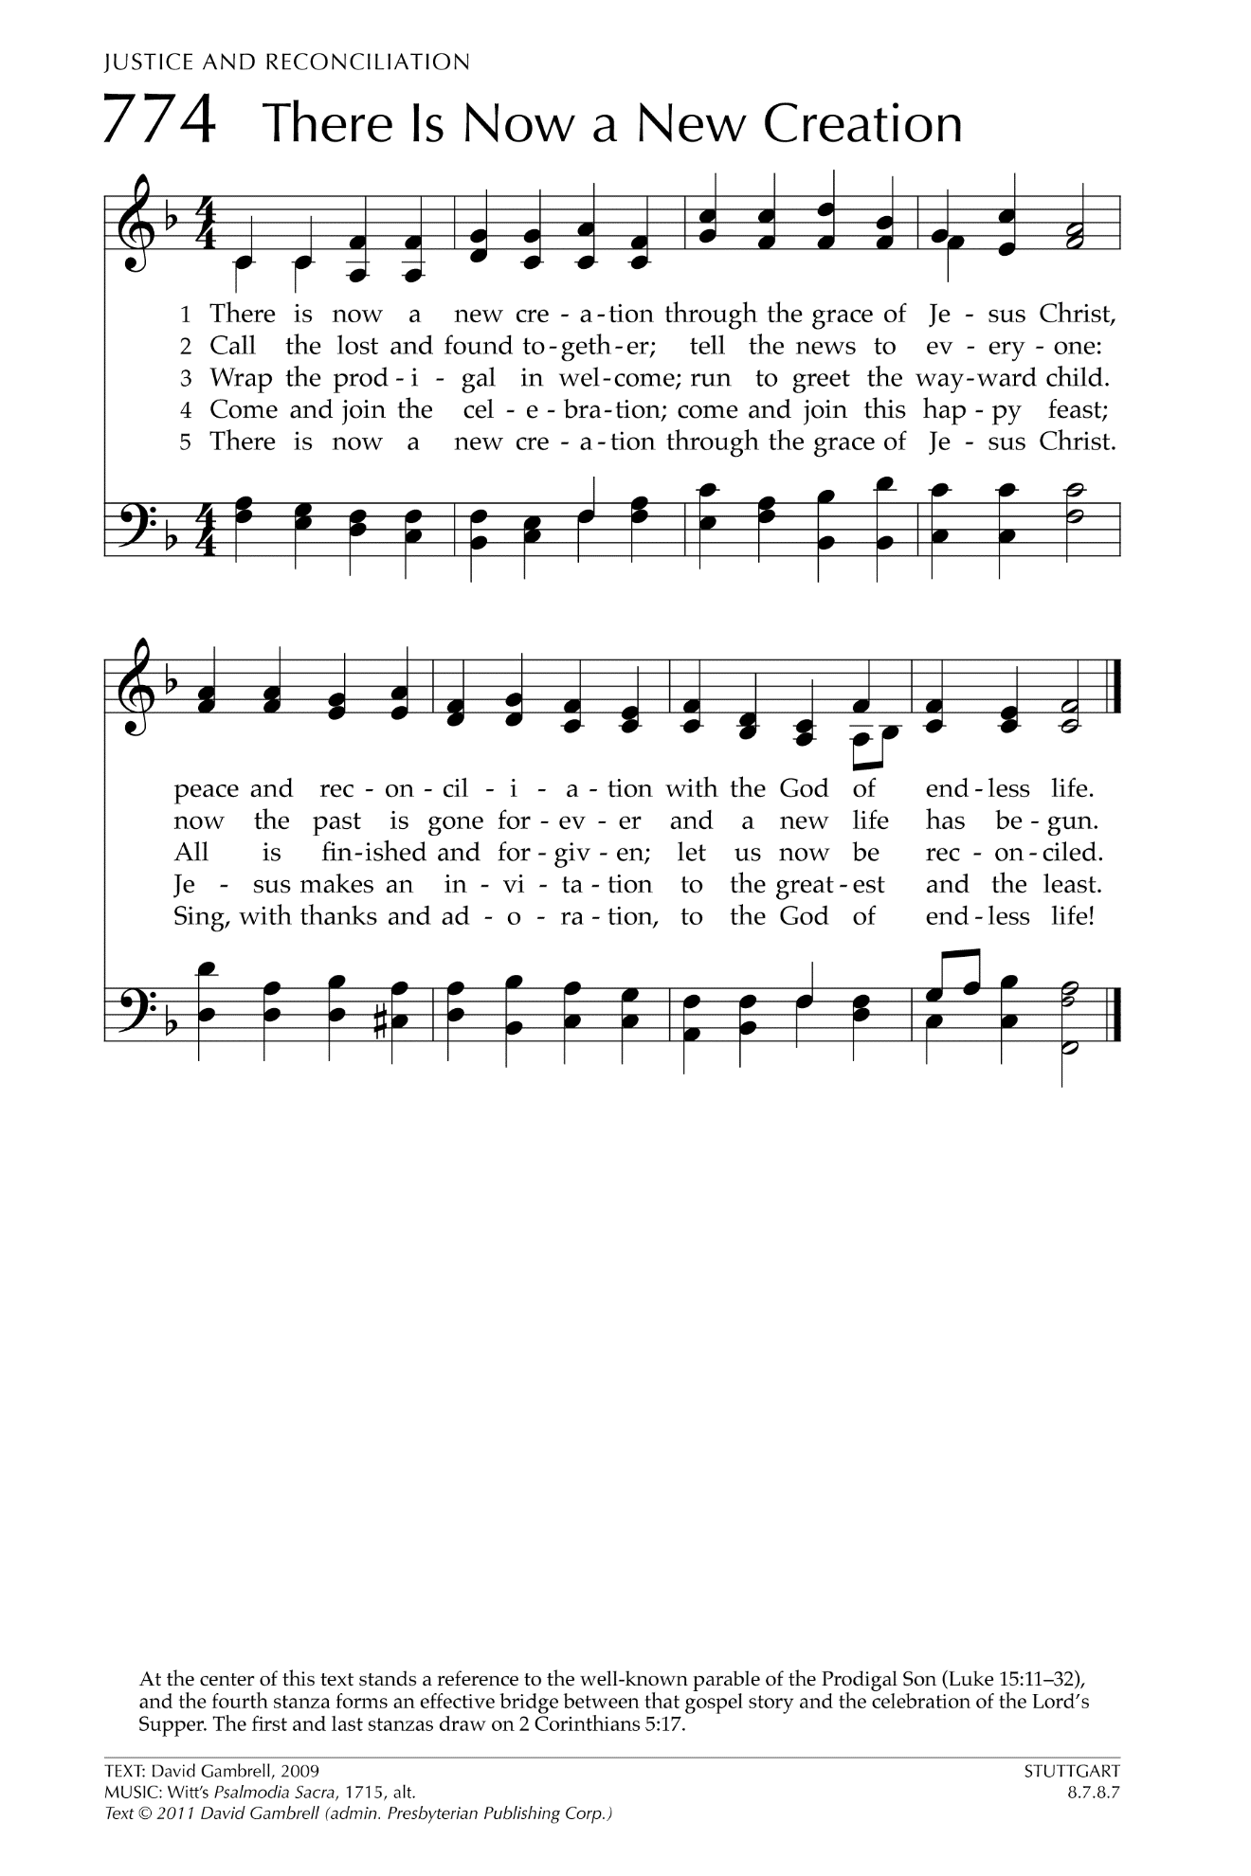

Let There Be Peace on Earth

Let there be peace on earth
And let it begin with me
Let there be peace on earth
The peace that was meant to be
With God as our Father
Christians all are we
Let us walk with each other
In perfect harmony.
Let peace begin with me
Let this be the moment now.
With every step I take
Let this be my solemn vow
To take each moment and live
Each moment in peace eternally
Let there be Peace on Earth
And let it begin with me!

