The Holy Way Presbyterian Church

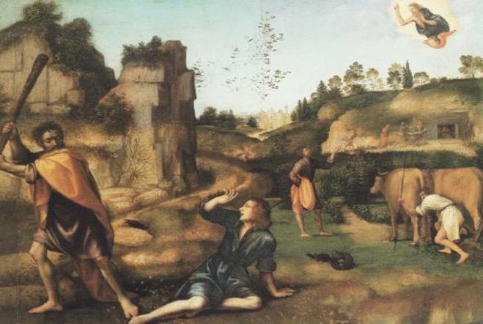

Tucson, Arizona
June 6, 2021 9:30 a.m.
In The Beginning God Created…

Meditation: Cain and Abel, one person had a gift to tend sheep, the other to tend the ground Both brought their offering to the Lord, yet the Lord did not respect Cain’s offering. Why? To the reader, it seems unfair, it appears God is showing prejudice for one sibling over the other. But is this true? Or does Yahweh see something in the heart that we do not see?

Welcome to Worship Rev. Tina Salvaneschi
Opening Prayer

Introit: For The Beauty of The Earth (Hymn 14, V.3)
Ryan Phillips, Director of Music

Hymn: I Want to Be As Close To You (Hymn 736)
Ryan Phillips, Director of Music

Call to Worship: Joan Valenzuela, Lay Leader

Leader: Day by Day, God leads us,
People: to the deep, deep pools of peace,
to the green, lush lawns of grace

Leader: Day by Day, Jesus calls us,
People: to pour out ourselves in service,
to anoint the stranger with hope

Leader: Day by Day, the Holy Spirit show us
People: the community we could be
the family we are called to become Amen

Prayers for the People Rev. Tina Salvaneschi
& The Lord’s Prayer

Our Father, who art in heaven, hallowed be thy name. Thy kingdom come, thy will be done on earth as it is in heaven. Give us this day our daily bread, and forgive us our debts as we forgive our debtors. And lead us not into temptation, but deliver us from evil, for thine is the kingdom and the power and the glory forever. Amen

Anthem: My Grateful Spirit Sings Ryan Phillips, Director of Music

Invitation for Tithes and Offering: Rev. Tina Salvaneschi

Offertory Music: Dr. Astrid Chan
(offering baskets available at all four exits as you leave)

Scripture Reading: Genesis 4:1-12 Joan Valenzuela, Lay Leader
4 Now Adam knew Eve his wife, and she conceived and bore Cain, and said, “I have acquired a man from the Lord.” 2 Then she bore again, this time his brother Abel. Now Abel was a keeper of sheep, but Cain was a tiller of the ground. 3 And in the process of time it came to pass that Cain brought an offering of the fruit of the ground to the Lord. 4 Abel also brought of the firstborn of his flock and of their fat. And the Lord respected Abel and his offering, 5 but He did not respect Cain and his offering. And Cain was very angry, and his countenance fell.
6 So the Lord said to Cain, “Why are you angry? And why has your countenance fallen? 7 If you do well, will you not be accepted? And if you do not do well, sin lies at the door. And its desire is for you, but you should rule over it.”
8 Now Cain talked with Abel his brother; and it came to pass, when they were in the field, that Cain rose up against Abel his brother and killed him. 9 Then the Lord said to Cain, “Where is Abel your brother?” He said, “I do not know. Am I my brother’s keeper?”
10 And He said, “What have you done? The voice of your brother’s blood cries out to Me from the ground. 11 So now you are cursed from the earth, which has opened its mouth to receive your brother’s blood from your hand. 12 When you till the ground, it shall no longer yield its strength to you. A fugitive and a vagabond you shall be on the earth.”
Leader: This is the Word of the Lord. People: Thanks be to God.

Communion: Servers, Sharon Groves, Marquita McCrone, Ginger Manly
Words of Institution Rev. Tina Salvaneschi

(We are serving Communion by Intinction this morning with Covid Safety in mind. Ushers will welcome you forward where Pastor and servers have bread and juice. For those unable to come forward, we will come to your seat. Please be mindful of social distancing, and enjoy this time as we experience Communion together…)

Communion Hymn: I’m Gonna Eat At the Welcome Table (Hymn 770)
Ryan Phillips, Director of Music

Sending Hymn: Fight the Good Fight (Hymn 846)
Ryan Phillips, Director of Music

Benediction: 2 Corinthians 13:14 Rev. Tina Salvaneschi

Song: Let There Be Peace on Earth Ryan Phillips, Director of Music

Postlude: Dr. Astrid Chan

What’s New At the Holy Way?

“Sermon Debrief Bible Study” - Tuesday 10:00 a.m. Zoom
Come dive deeper into Sunday’s sermon and study the history, context, signs and meaning of God’s Word and how the Scriptures can apply to our lives today. This is lead by Pastor Tina and is very interactive!

“Thoughtful Thursdays” - (Cancelled June 10th, See you the Following week!)
This is a great way to stay connected (especially for our snowbirds, and folks that can’t make it to in-person services!). We share about our lives, spend time talking, share joys, pray requests…and anything else that comes up. Oh yes, laughter seems to happen too. This is group lead, with Pastor Tina and for women AND men!

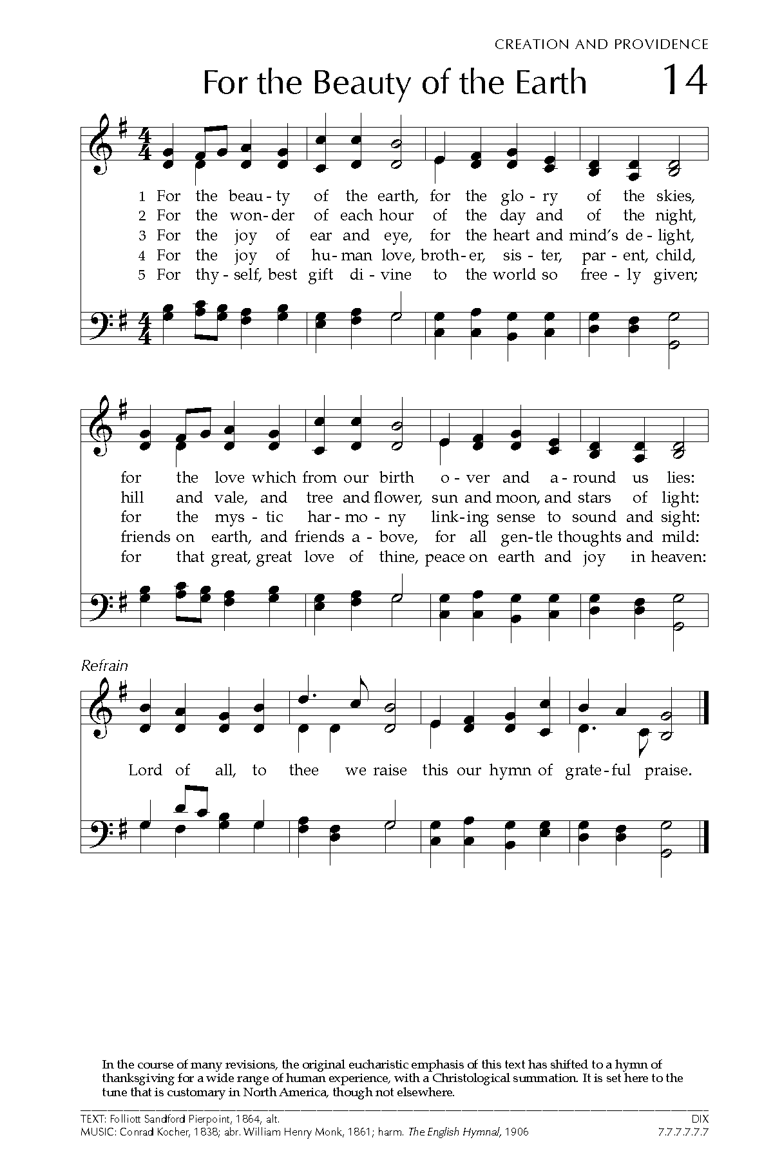
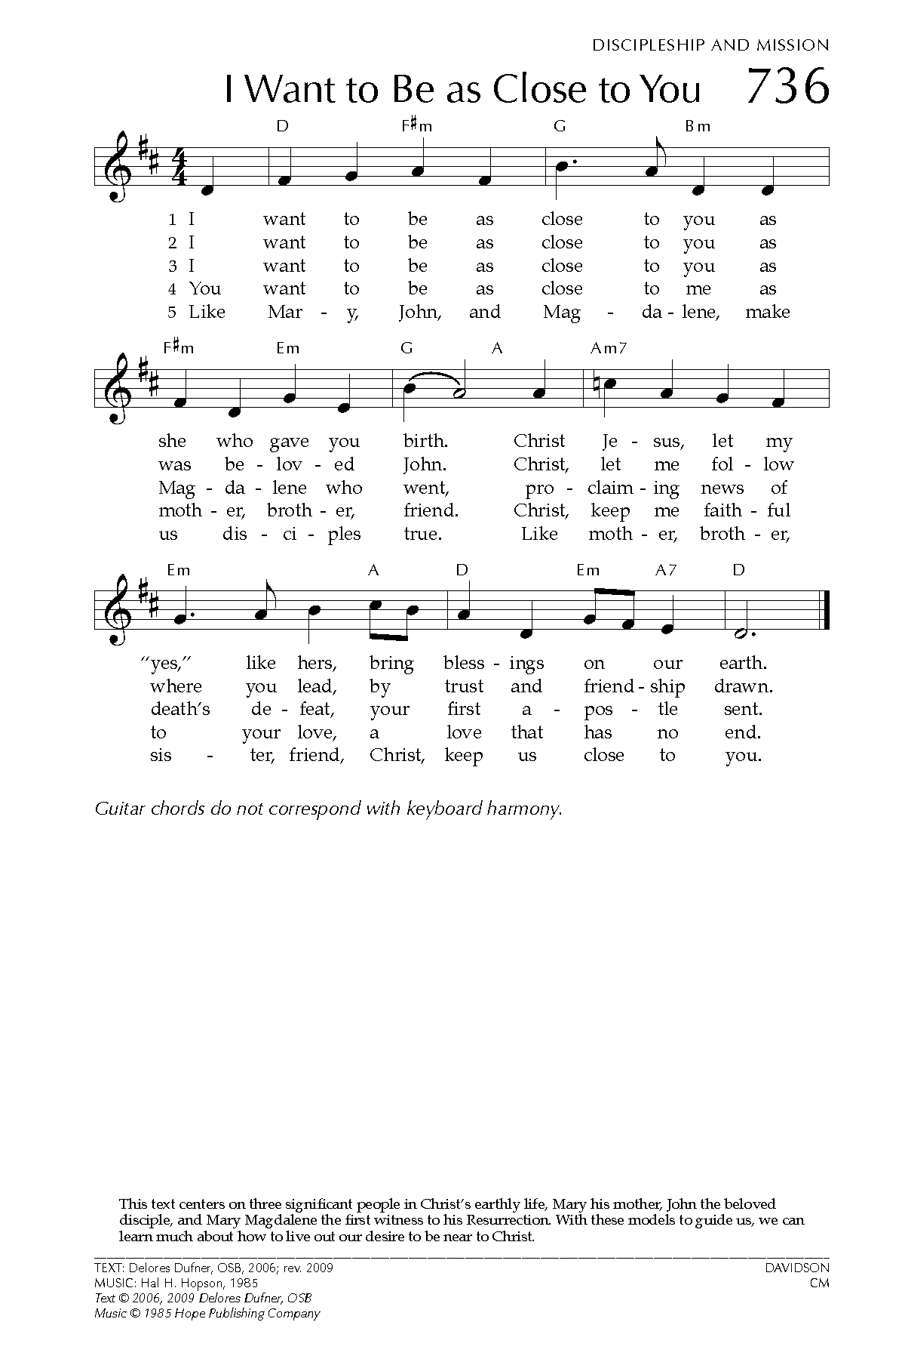
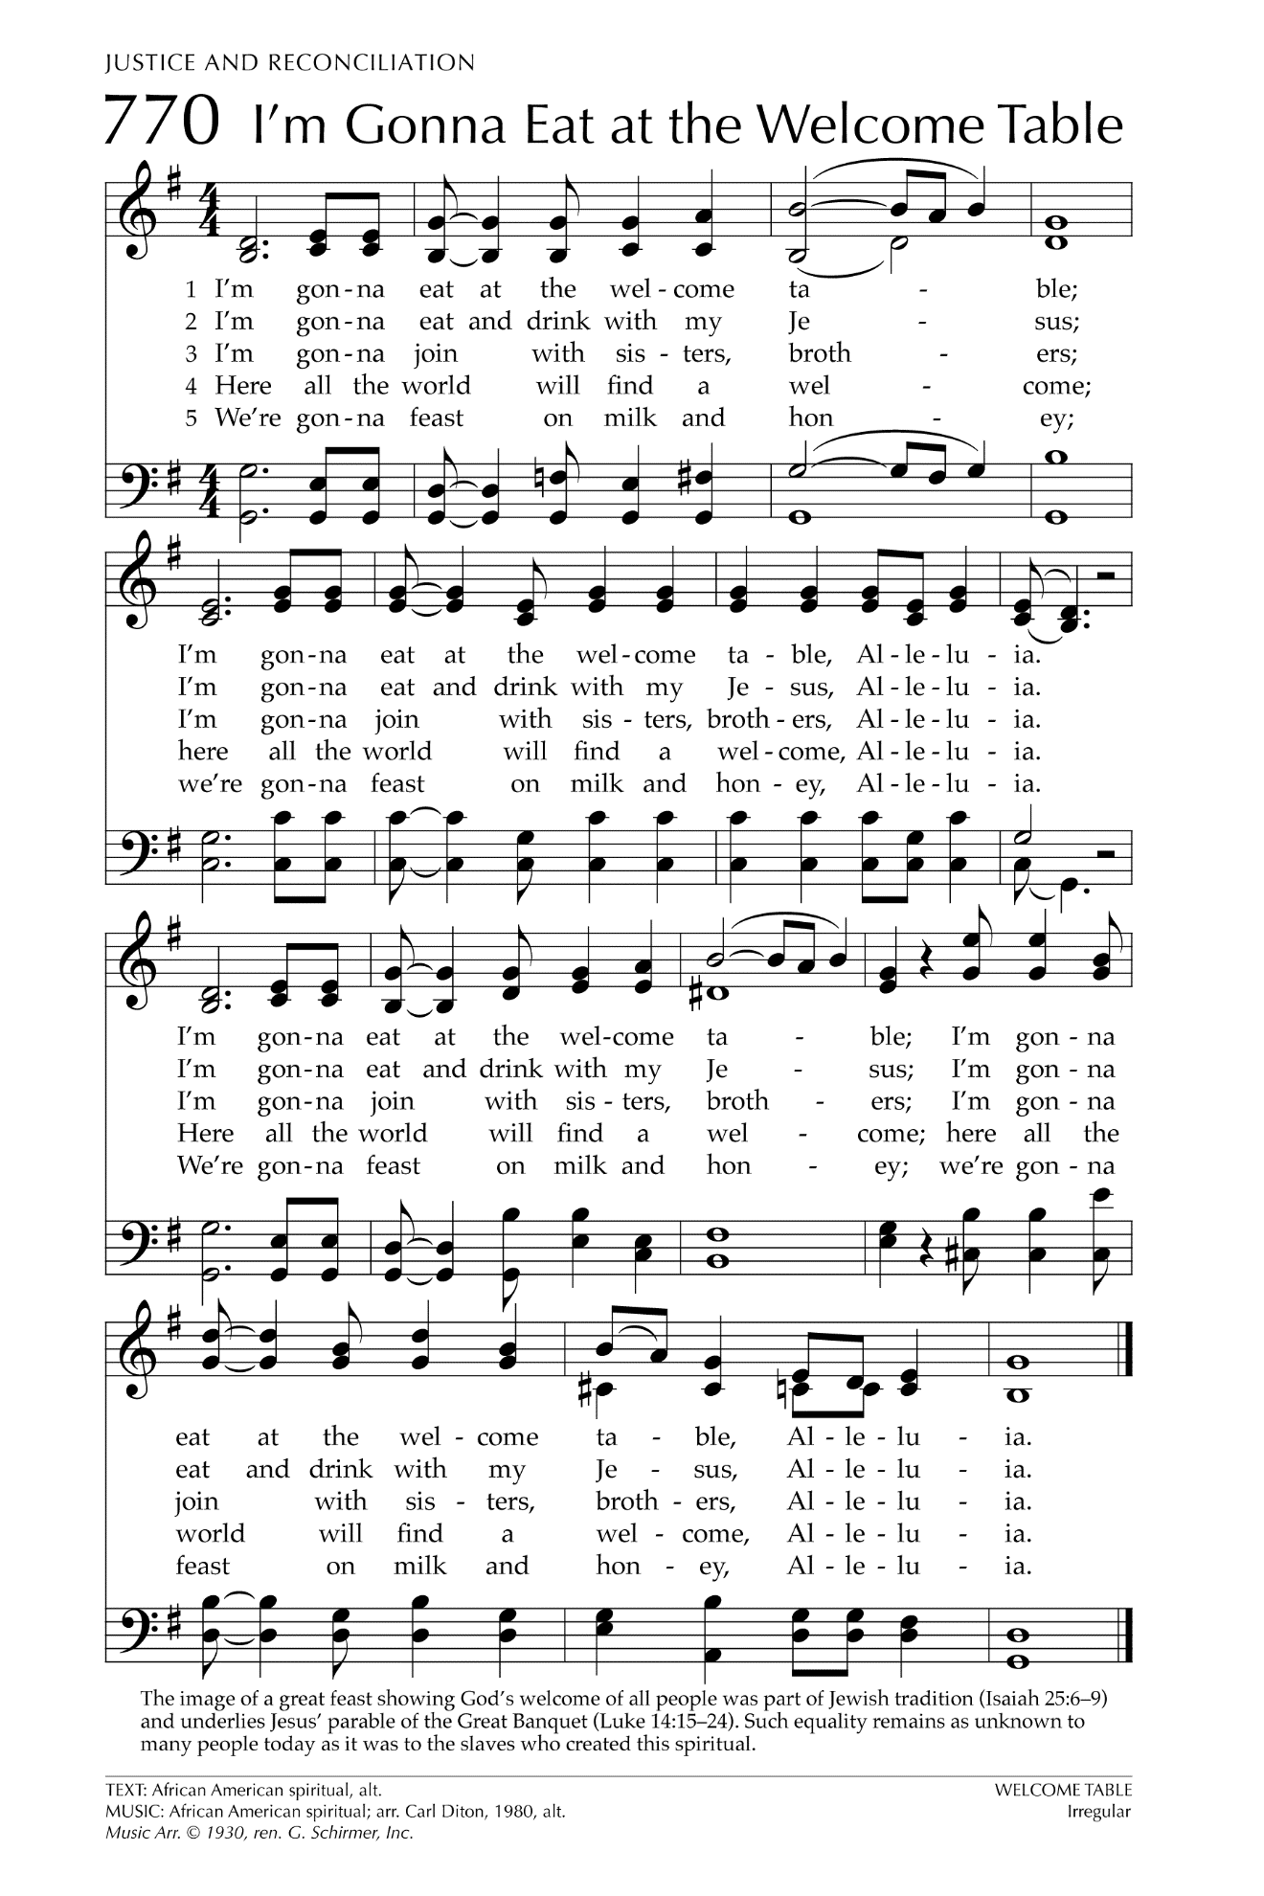
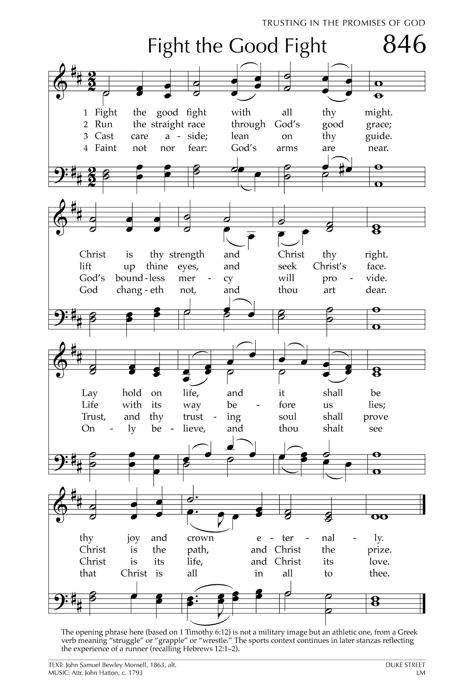

Let There Be Peace on Earth

Let there be peace on earth
And let it begin with me
Let there be peace on earth
The peace that was meant to be
With God as our Father
Christians all are we
Let us walk with each other
In perfect harmony.
Let peace begin with me
Let this be the moment now.
With every step I take
Let this be my solemn vow
To take each moment and live
Each moment in peace eternally
Let there be Peace on Earth
And let it begin with me!

