The Holy Way Presbyterian Church

Tucson, Arizona

October 31, 2021 9:30 a.m.
Trusting In God Brings Comfort...

Meditation: This is the Waterfall Erawan in Kanchanaburi, Thailand. For it is the God who commanded light to shine out of darkness, who has shone in our hearts to give the light of the knowledge of the glory of God in the face of Jesus Christ.

Welcome to Worship Rev. Tina Salvaneschi
Opening Prayer
Release Children to Sunday School - Miss Kathy
Introit: God of Grace and God of Glory (Hymn 307, Vs 4)
Ryan Phillips, Choir Director

Hymn: Lord of All Hopefulness (Hymn 683) Ryan Phillips, Choir Director

Call to Worship: Lay Leader, Bill Boals
Creator and Ruler of the Earth, we lift up our voices, our eyes, our hearts, our lives to You in praise. Make us Your alleluia people. Uphold the weary, for whom praise may be very difficult. Humble the strong, for whom “alleluia” may be too easy. Creator and Ruler of the Earth, continue to form us into Your new creation, that we might welcome You to more fully become the ruler of our hearts and minds. Through Him who came as a servant, and who now reigns over all creation, Jesus, our Christ.

People: Amen

Birthday’s and Anniversaries Stephen Levine
Celebrations, Joys and Concerns Rev. Tina Salvaneschi
The People of the Congregation Share Joys and Concerns

...The Lord’s Prayer
People: Our Father, who art in heaven, hallowed be thy name. Thy kingdom come, thy will be done on earth as it is in heaven. Give us this day our daily bread, and forgive us our debts as we forgive our debtors. And lead us not into temptation, but deliver us from evil, for thine is the kingdom and the power and the glory forever. Amen

Anthem: Seek and Ye Shall Find Chancel Choir
Tithes and Offering: Prayer Rev. Tina Salvaneschi
(Option: Place you index card with a private prayer for Pastor)
(Option: write on index card a word or two what giving to God means to you place index cards in plate)

Offertory Music: Dr. Astrid Chan

Doxology: (Hymn 606) Ryan Phillips, Choir Director
Praise God, from whom all blessings flow;
praise God all creatures here below;
praise God above, ye heavenly host;
praise Father, Son, and Holy Ghost. Amen.

Scripture Reading: Lay Leader, Bill Boals
II Corinthians 4:7-16
7 But we have this treasure in earthen vessels, that the excellence of the power may be of God and not of us. 8 We are hard-pressed on every side, yet not crushed; we are perplexed, but not in despair; 9 persecuted, but not forsaken; struck down, but not destroyed— 10 always carrying about in the body the dying of the Lord Jesus, that the life of Jesus also may be manifested in our body. 11 For we who live are always delivered to death for Jesus’ sake, that the life of Jesus also may be manifested in our mortal flesh. 12 So then death is working in us, but life in you. 13 And since we have the same spirit of faith, according to what is written, “I believed and therefore I spoke,” we also believe and therefore speak, 14 knowing that He who raised up the Lord Jesus will also raise us up with Jesus, and will present us with you. 15 For all things are for your sakes, that grace, having spread through the many, may cause thanksgiving to abound to the glory of God. Seeing the Invisible 16 Therefore we do not lose heart. Even though our outward man is perishing, yet the inward man is being renewed day by day.
Leader: This is the Word of the Lord. People: Thanks be to God.

Message: “Gods Power Gives Life” Rev. Tina Salvaneschi

Sending Hymn: I’ll Praise My Maker (Hymn 806)
Ryan Phillips, Choir Director

Benediction: 2 Corinthians 13:14 Rev. Tina Salvaneschi

Song: Let There Be Peace On Earth Ryan Phillips, Choir Director
Postlude: Dr. Astrid Chan

Stay Connected at The Holy Way
“Sermon Debrief Bible Study in person on Campus and Zoom” - Tuesday 10:00 a.m.
It’s Both! Come and meet live in the Conference Room at 10:00 a.m. or join on Zoom and we will conference you in on the big screen!
This is a great way to get to Fellowship, wrestle with questions about Sunday’s sermon, ponder the meaning of God’s Word, and discover how Scriptures can transform our lives today. This is led by Pastor Tina and is interactive! Come join the live class if you are able!

“Thoughtful Thursdays” - Thursday 10:00 a.m. Zoom Only
This is a great way to stay connected (especially for our snowbirds, and folks that can’t make it to in-person services!). We share about our lives, spend time talking, share joys, prayer requests…and anything else that comes up. Oh yes, laughter seems to happen too. This is group led, with Pastor Tina and for women AND men!

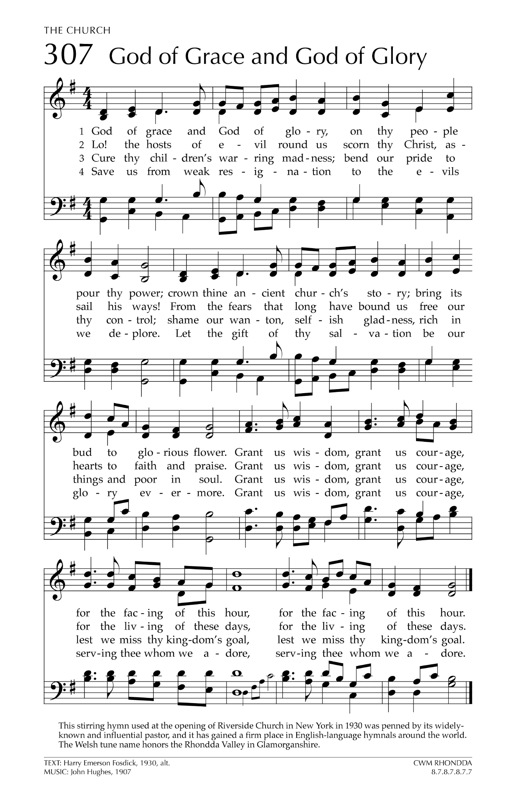
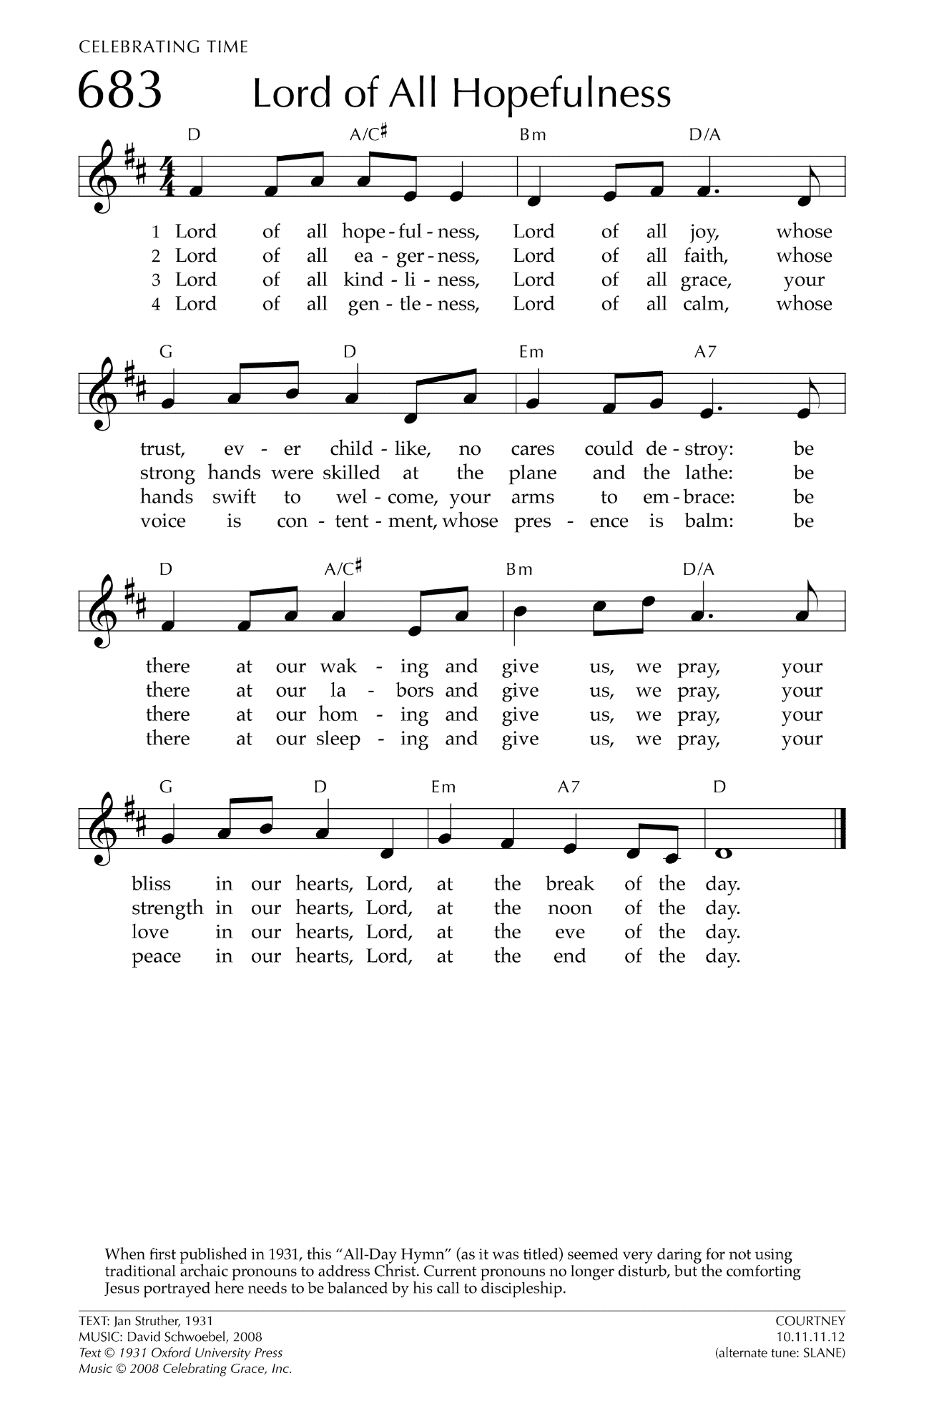
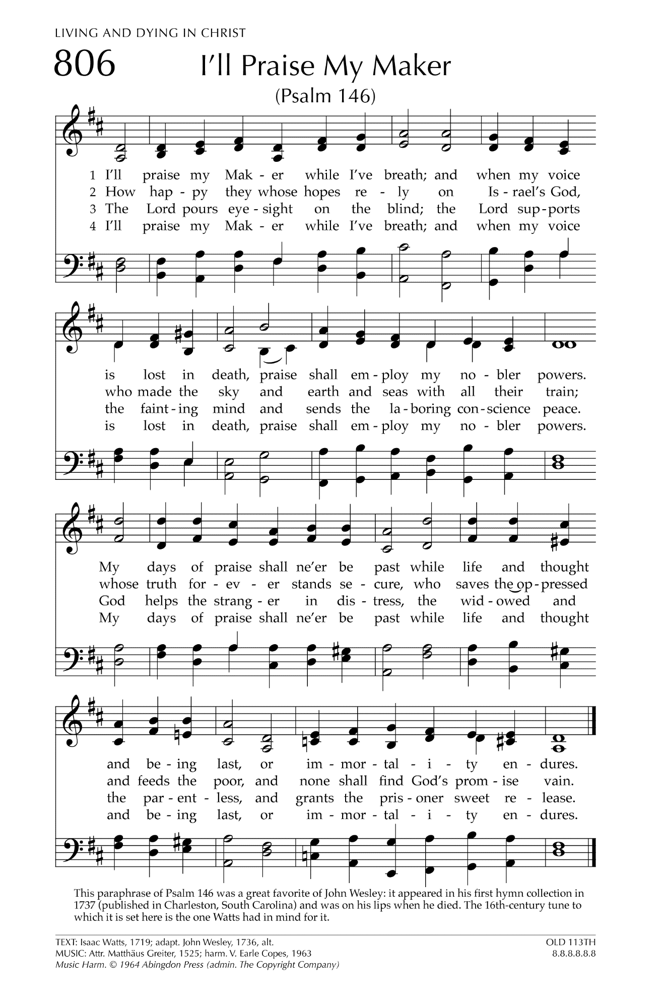

Let There Be Peace on Earth

Let there be peace on earth
And let it begin with me
Let there be peace on earth
The peace that was meant to be
With God as our Father
Christians all are we
Let us walk with each other
In perfect harmony.
Let peace begin with me
Let this be the moment now.
With every step I take
Let this be my solemn vow
To take each moment and live
Each moment in peace eternally
Let there be Peace on Earth
And let it begin with me!

