The Holy Way Presbyterian Church

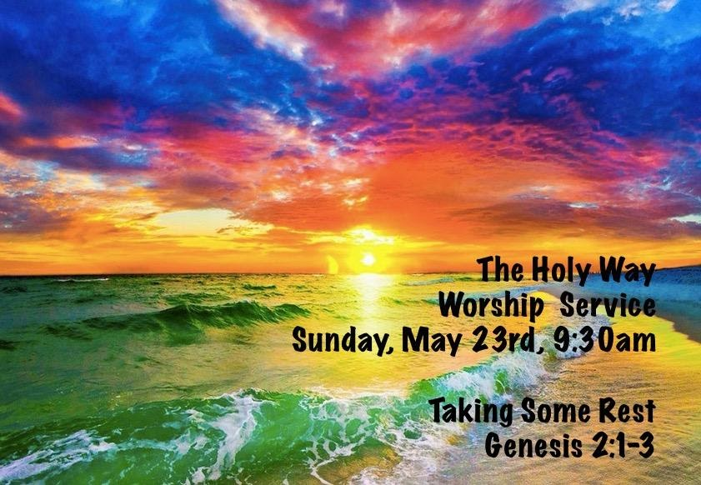

Tucson, Arizona
May 23, 2021 9:30 a.m.

Welcome to Worship Rev. Tina Salvaneschi
Opening Prayer

Introit: For the Beauty of The Earth (Hymn 14, Vs 1)
Ryan Phillips, Director of Music

Hymn: As the Wind Song (Hymn 292) Ryan Phillips, Director of Music

Call to Worship: Sherri Atleson, Lay Leader

Leader: Come, Lord God, to receive our worship. Come, Lord Jesus, to receive our praise. Come, Holy Spirit, to receive our thanks. Come, eternal three-in-one God, come where we are gathered to celebrate our unity as your body, the church.

People: We share one faith and are of one soul and one mind, which belong solely and wholly to you.

Leader: We are baptized with one baptism, eat of one bread and drink of one cup.

People: We confess one name above all other names; we are obedient to one Lord, who frees us from the tyranny and hatefulness of the world.

Leader: We share one hope, one comfort, one goal.

People: We are one people, united--despite any noticeable differences--by our faith in you, Lord Jesus.

Leader: We are one people, united by your love and mercy to stand against any power that would try to tear us apart.

People: We are one people, united in blessing and in suffering, united in joy and in sorrow, united in strength and in weakness. Receive our praise! Amen.

Prayers for the People Rev. Tina Salvaneschi
The People of the Congregation Share

…The Lord’s Prayer
Our Father, who art in heaven, hallowed be thy name. Thy kingdom come, thy will be done on earth as it is in heaven. Give us this day our daily bread, and forgive us our debts as we forgive our debtors. And lead us not into temptation, but deliver us from evil, for thine is the kingdom and the power and the glory forever. Amen

Anthem: How Great Is Our God/How Great Thou Art Ryan Phillips, Director of Music
Invitation for the Offering 2 Corinthians 9:7 Rev. Tina Salvaneschi
So let each one give as he purposes in his heart, not grudgingly or of necessity; for God loves a cheerful giver.
Offertory Dr. Astrid Chan
(offering baskets available at exits as you leave)

Scripture Reading: Genesis 2:1-3 Sherri Atleson, Lay Leader,
Thus the heavens and the earth, and all the host of them, were finished. And on the seventh day God ended His work which He had done, and He rested on the seventh day from all His work which He had done. Then God blessed the seventh day and sanctified it, because in it He rested from all His work which God had created and made.

Leader: This is the Word of the Lord. People: Thanks be to God.

Message Taking Some Rest Rev. Tina Salvaneschi

Sending Hymn We Will Go Out With Joy (Hymn 539)
Ryan Phillips, Director of Music

Benediction 2 Corinthians 13:14 Rev. Tina Salvaneschi

Let There Be Peace on Earth Ryan Phillips, Director of Music

Postlude Dr. Astrid Chan

What’s New At the Holy Way?

“Sermon Debrief Bible Study” - Tuesday 10:00 a.m. Zoom
Come dive deeper into Sunday’s sermon and study the history, context, signs and meaning of God’s Word and how the Scriptures can apply to our lives today. This is led by Pastor Tina and is very interactive.

“Thoughtful Thursdays” - Thursday 10:00 a.m. Zoom
This replaced Fellowship Fridays and is a great way to stay connected especially with each other, especially for our snowbirds! We share our lives, spend time, share joys, prayer requests…and anything else that comes up. Oh yes, laughter seems to happen too. This is group led, with Pastor Tina praying for needs.

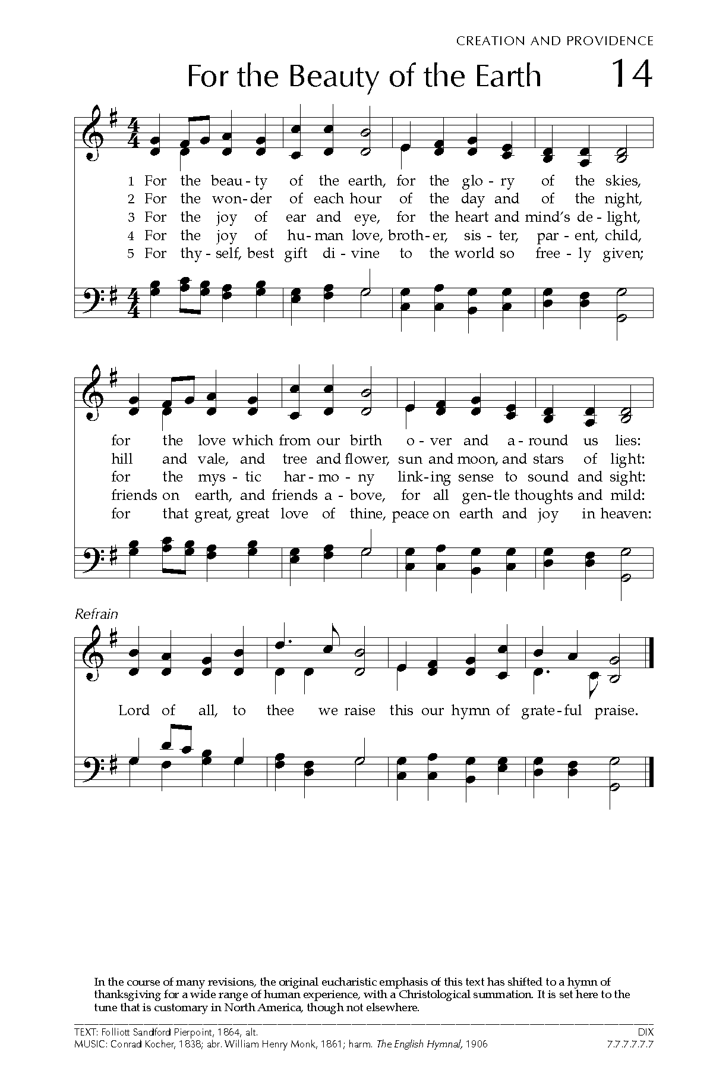
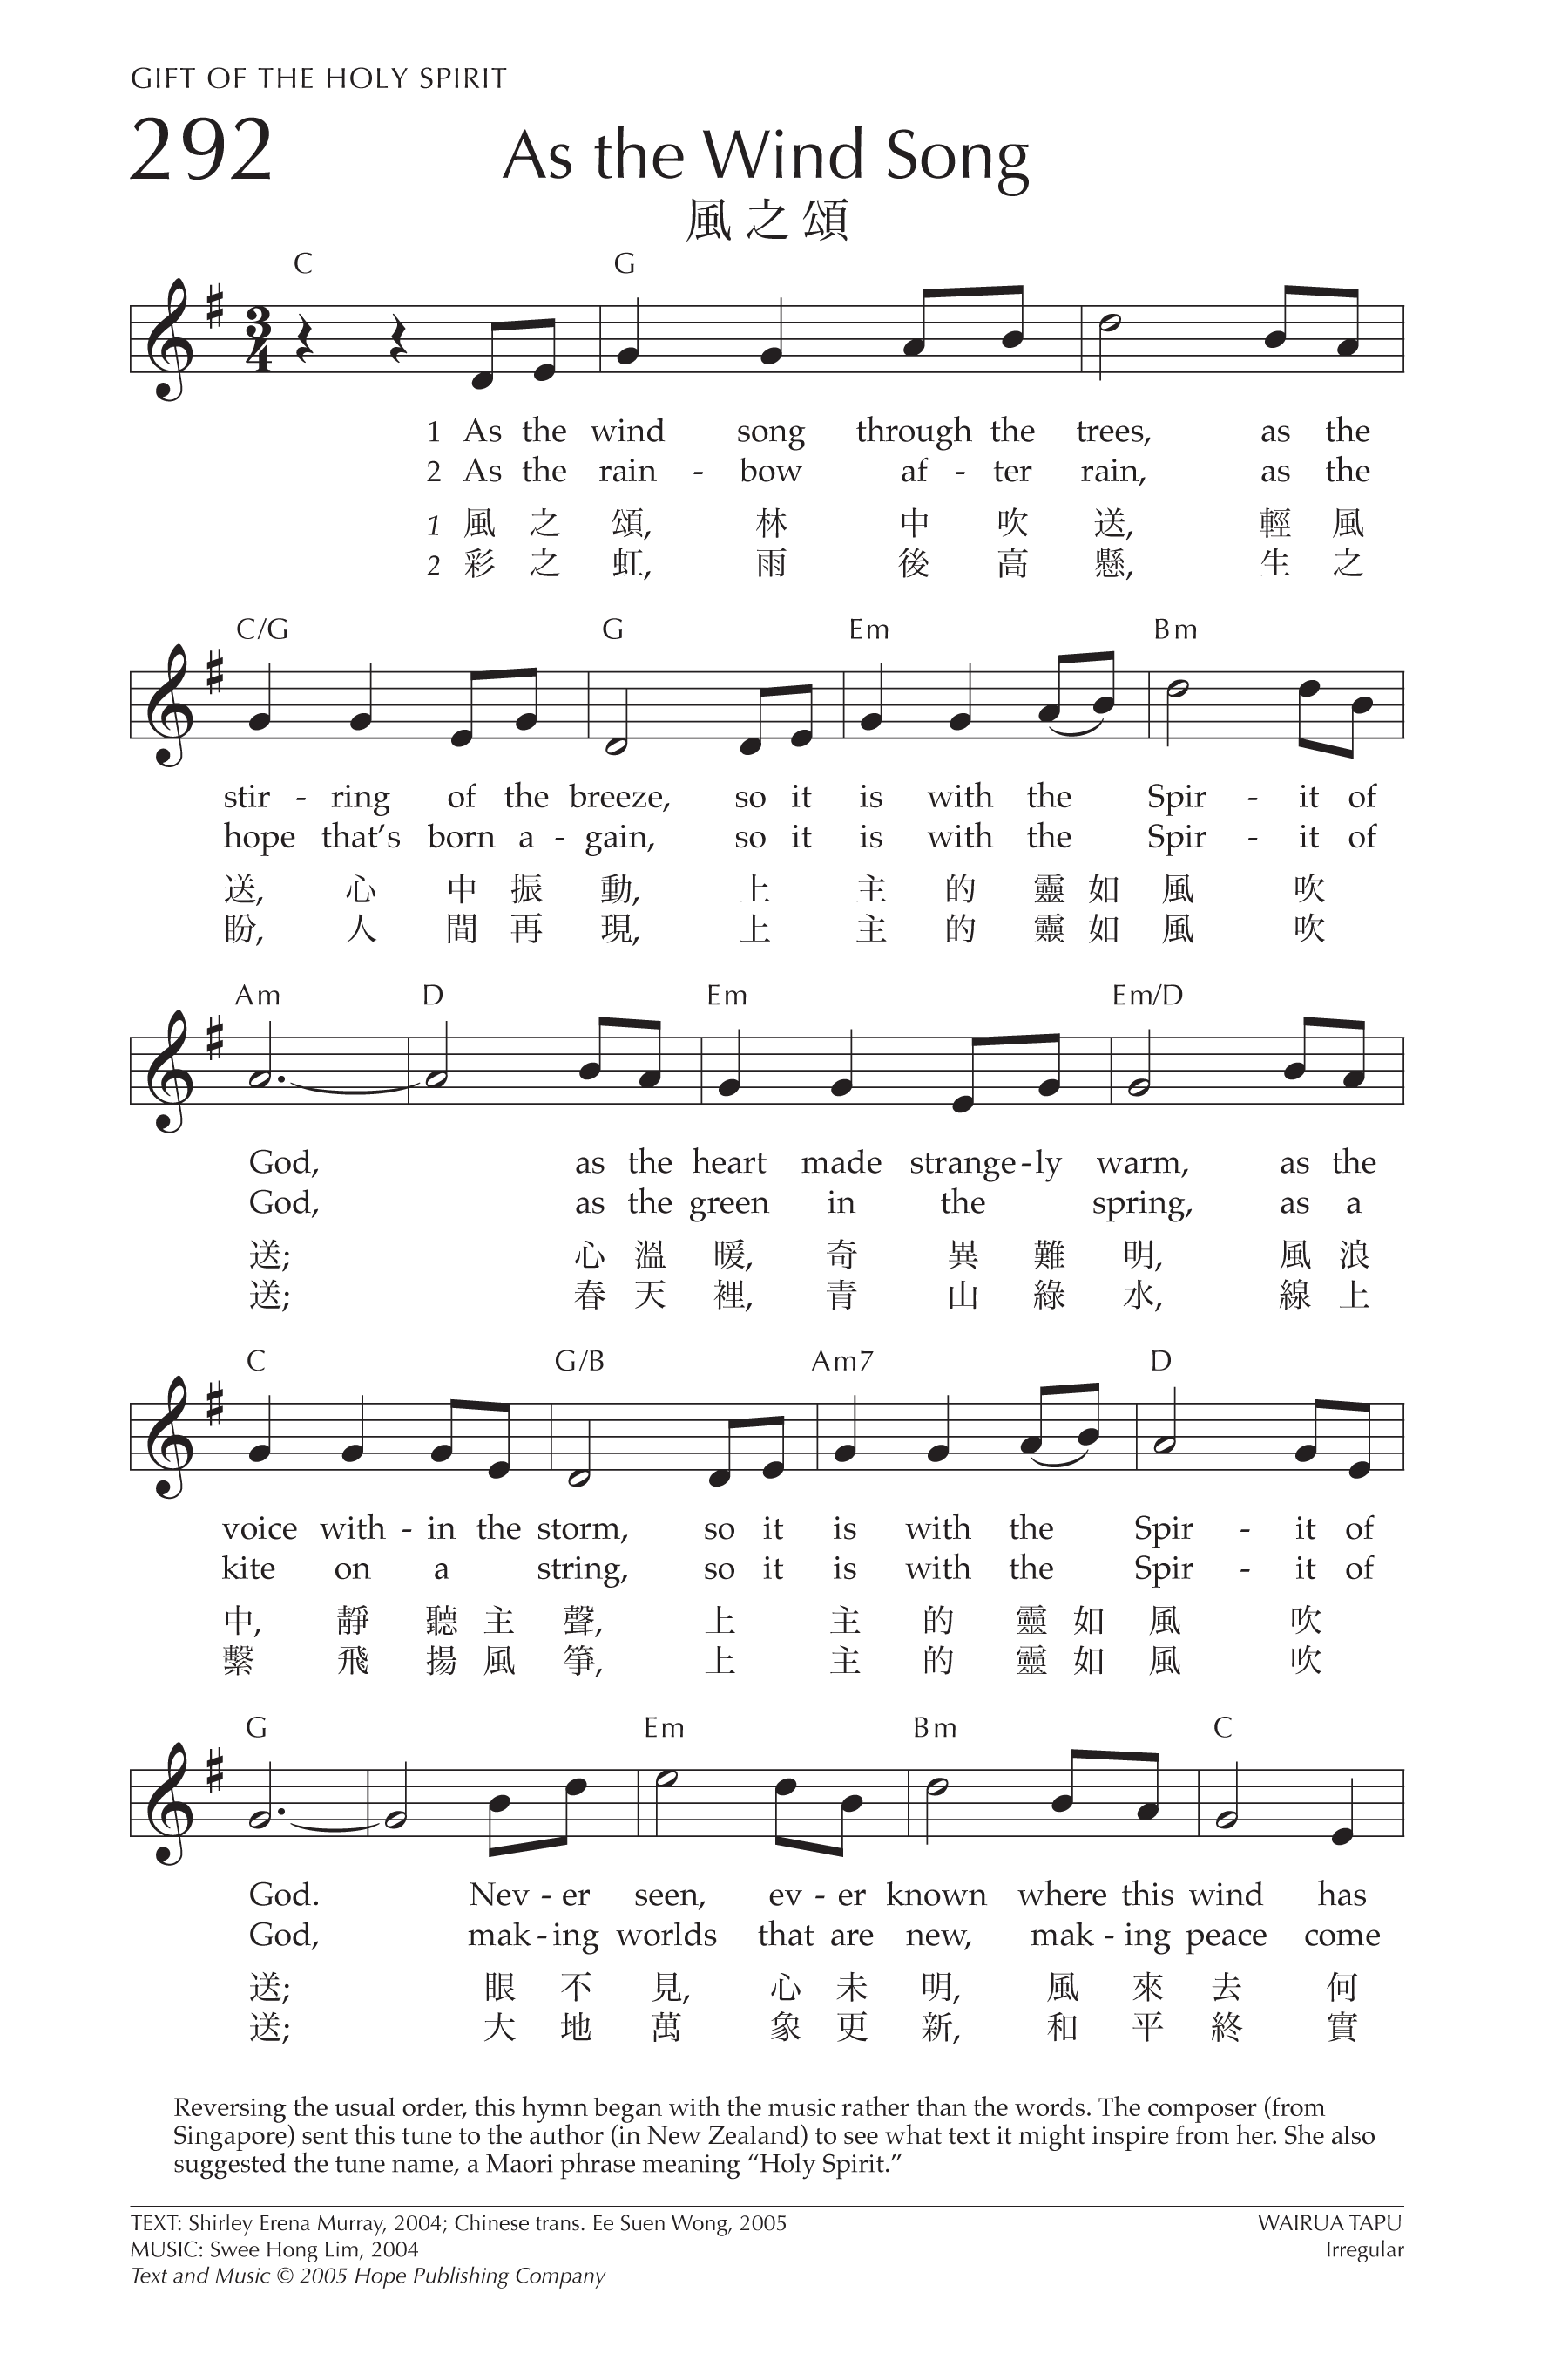
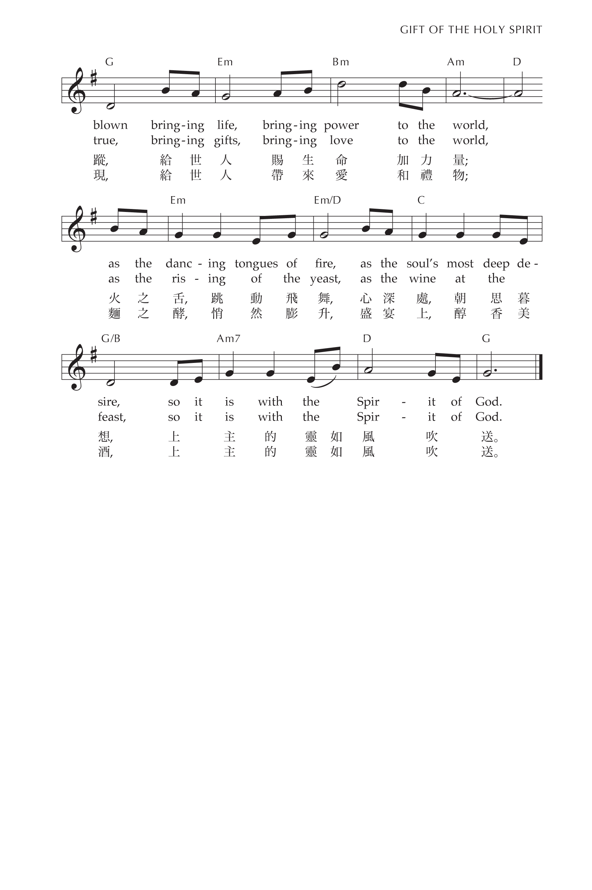
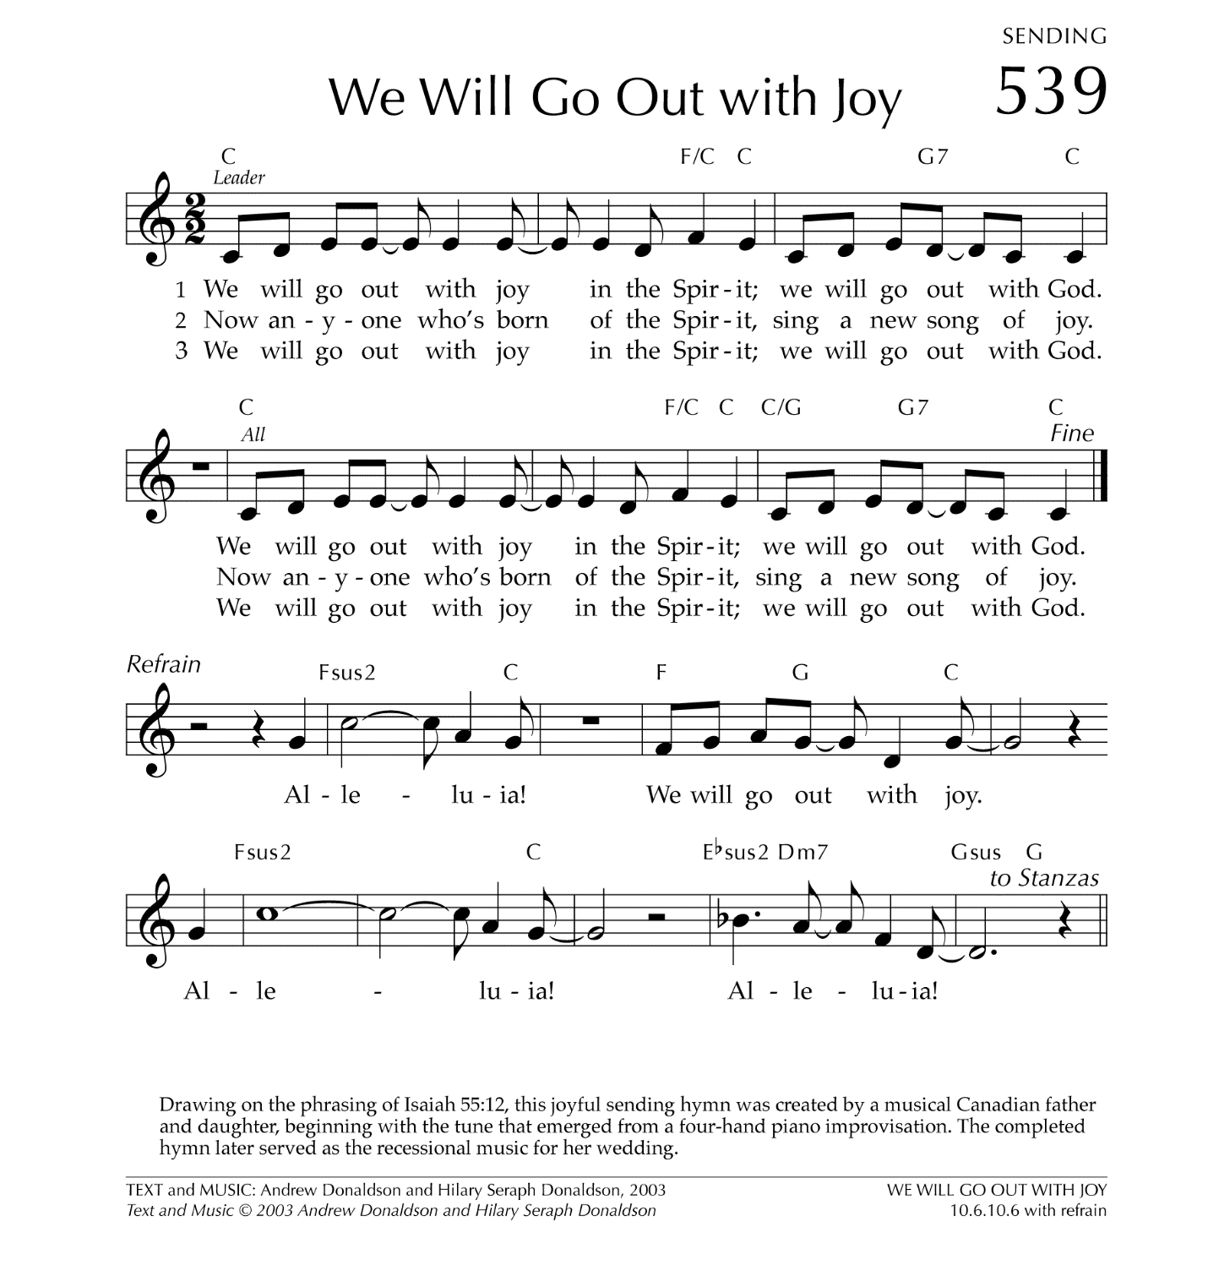

Let There be Peace on Earth

Let there be peace on earth
And let it begin with me
Let There Be Peace on Earth
The peace that was meant to be
With God as our Father
Christians all are we
Let us walk with each other
In perfect harmony.
Let peace begin with me
Let this be the moment now.
With every step I take
Let this be my solemn vow
To take each moment and live
Each moment in peace eternally
Let there be Peace on Earth
And let it begin with me!

