The Holy Way Presbyterian Church

Tucson, Arizona
July 4th, 2021 9:30 a.m.
Living In Community...

Words of Meditation - The Spiritual Blessings of Christ in a nutshell are that we are destined for adoption into a family, we have been redeemed, and we have obtained an inheritance. Let us then live for the praise of His glory.

Welcome to Worship
Opening Prayer Rev. Tina Salvaneschi

Introit: I Sing The Mighty Power of God (Hymn #32, V. 1)
Sinamar Pascua Respicio, Guest

Hymn: A Sower Came From Ancient Hills (Hymn #171, V. all) Sinamar Pascua Respicio, Guest

Call to Worship: Lay Leader, Don Kimball

Grace and peace to you from God our Father,
who has blessed us with every spiritual blessing
that comes from heaven:
who knew you and chose you before the world began;
who loves you so much that he calls you his own children;
who has brought you from darkness into light
and filled you with his glorious power;
who has prepared an inheritance for you
that will never spoil or fade;
who encourages and strengthens you
in every good deed and word;
who comforts you in your troubles
so that you can comfort others.
This is our God,
the ultimate source of all things,
and the One for whom we live.
Let’s worship God together!

People: Amen

Birthday’s and Anniversaries Rev. Tina Salvaneschi
Celebrations, Joys and Concerns
The People of the Congregation Share

...The Lord’s Prayer
People: Our Father, who art in heaven, hallowed be thy name. Thy kingdom come, thy will be done on earth as it is in heaven. Give us this day our daily bread, and forgive us our debts as we forgive our debtors. And lead us not into temptation, but deliver us from evil, for thine is the kingdom and the power and the glory forever. Amen

Anthem: Your Heart Today Sinamar Pascua Respicio, Guest

Invitation for Tithes and Offering: Rev. Tina Salvaneschi

Offertory Music: Dr. Astrid Chan
(offering baskets available at all four exits as you leave)

Scripture Reading: Lay Leader, Don Kimball
Ephesians 1:3-14
3 Blessed be the God and Father of our Lord Jesus Christ, who has blessed us with every spiritual blessing in the heavenly places in Christ, 4 just as He chose us in Him before the foundation of the world, that we should be holy and without blame before Him in love, 5 having predestined us to adoption as sons by Jesus Christ to Himself, according to the good pleasure of His will, 6 to the praise of the glory of His grace, by which He made us accepted in the Beloved.
7 In Him we have redemption through His blood, the forgiveness of sins, according to the riches of His grace 8 which He made to abound toward us in all wisdom and prudence, 9 having made known to us the mystery of His will, according to His good pleasure which He purposed in Himself, 10 that in the dispensation of the fullness of the times He might gather together in one all things in Christ, both which are in heaven and which are on earth—in Him.
11 In Him also we have obtained an inheritance, being predestined according to the purpose of Him who works all things according to the counsel of His will, 12 that we who first trusted in Christ should be to the praise of His glory.
13 In Him you also trusted, after you heard the word of truth, the gospel of your salvation; in whom also, having believed, you were sealed with the Holy Spirit of promise, 14 who is the guarantee of our inheritance until the redemption of the purchased possession, to the praise of His glory.
Leader: This is the Word of the Lord. People: Thanks be to God.

Message: Spiritual Blessings in Christ Rev. Tina Salvaneschi

Communion: Servers: Sherri Atleson, Jeannie Hollis, Joan Valenzuela
Ginger Manly
Words of Institution Rev. Tina Salvaneschi

(We are serving Communion by Intinction this morning with Covid Safety in mind. Ushers will welcome you forward on the sides of Sanctuary. Pastor and servers have bread and juice in front then you will return to your seat down the center aisle. For those unable to come forward, we will serve you at your seat. Please be mindful of social distancing, and enjoy this time as we experience Communion together…)

Communion Hymn: Loaves Were Broken, Words Were Spoken
(Hymn #498, V. 1) Sinamar Pascua Respicio, Guest

Sending Hymn: How Great Thou Art Sinamar Pascua Respicio, Guest

Benediction: 2 Corinthians 13:14 Rev. Tina Salvaneschi

Song: Let There Be Peace On Earth Sinamar Pascua Respicio, Guest

Postlude: Dr. Astrid Chan

What’s New at The Holy Way

“Sermon Debrief Bible Study in person on Campus and Zoom” - Tuesday 10:00 a.m!
It’s Both! Come and meet live in the Conference Room at 10:00 a.m. or join on Zoom and we will conference you in on the big screen!
We are starting our new series called “Living In Community” in the book of Ephesians so don’t miss out! This is a great way to get to know the Holy Way Folks and dive deeper into Sunday’s sermon, ask questions, ponder the meaning of God’s Word and discover how the Holy Scriptures can apply to our lives today. This is led by Pastor Tina and is very interactive! Come join the live class if you are able!

“Thoughtful Thursdays” - Thursdays 10:00 a.m. Zoom Only (for now...)
This is a great way to stay connected (especially for our snowbirds, and folks that can’t make it to in-person services!). We share about our lives, spend time talking, share joys, prayer requests…and anything else that comes up. Oh yes, laughter seems to happen too. This is group led, with Pastor Tina and for women AND men!

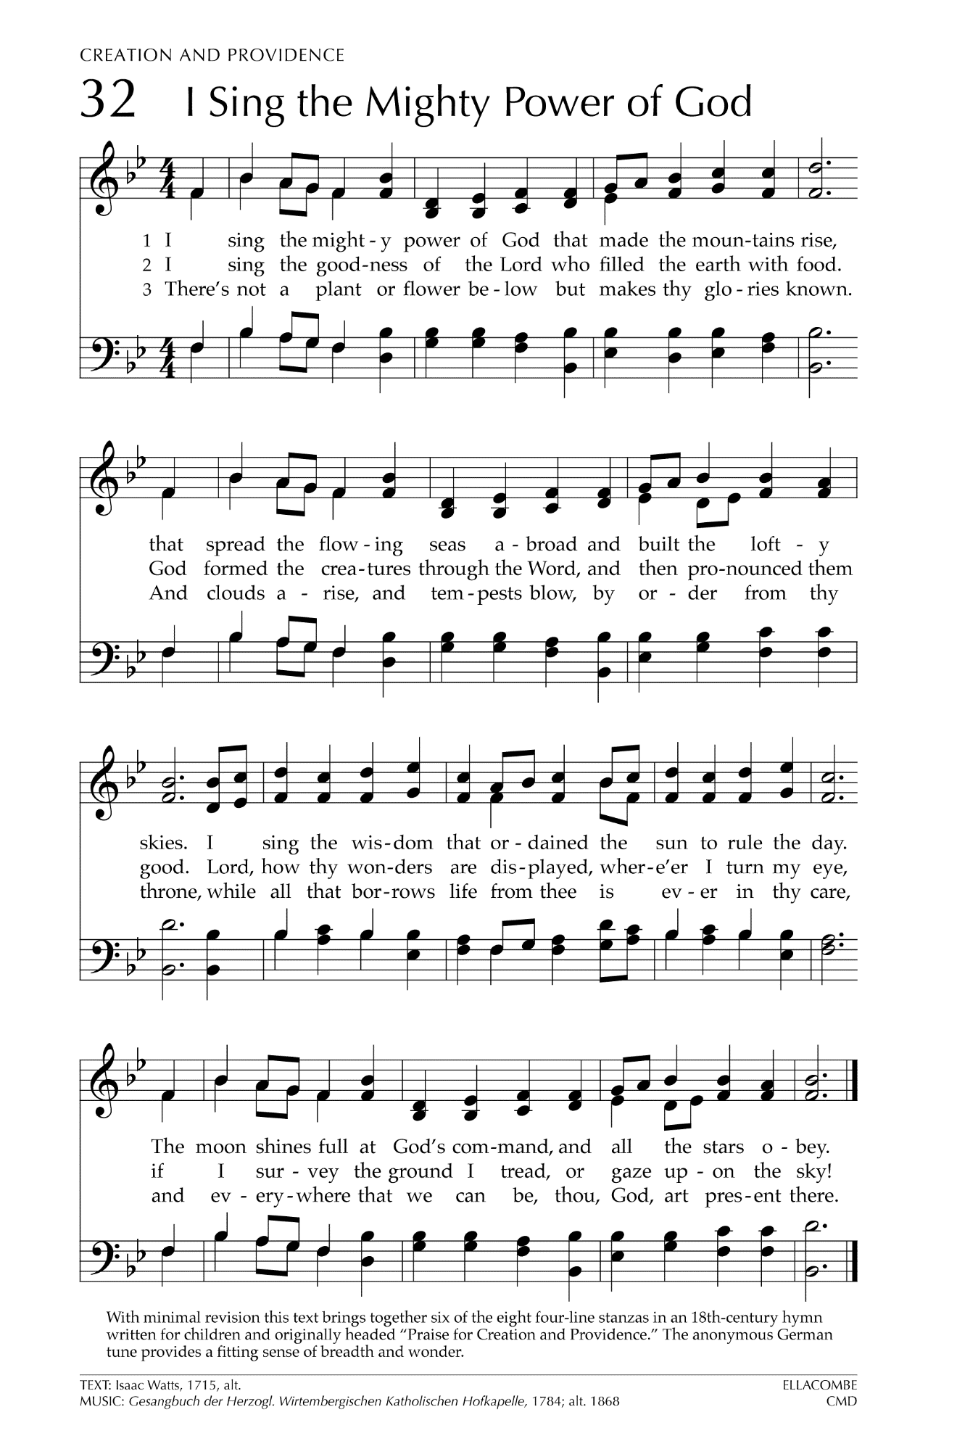
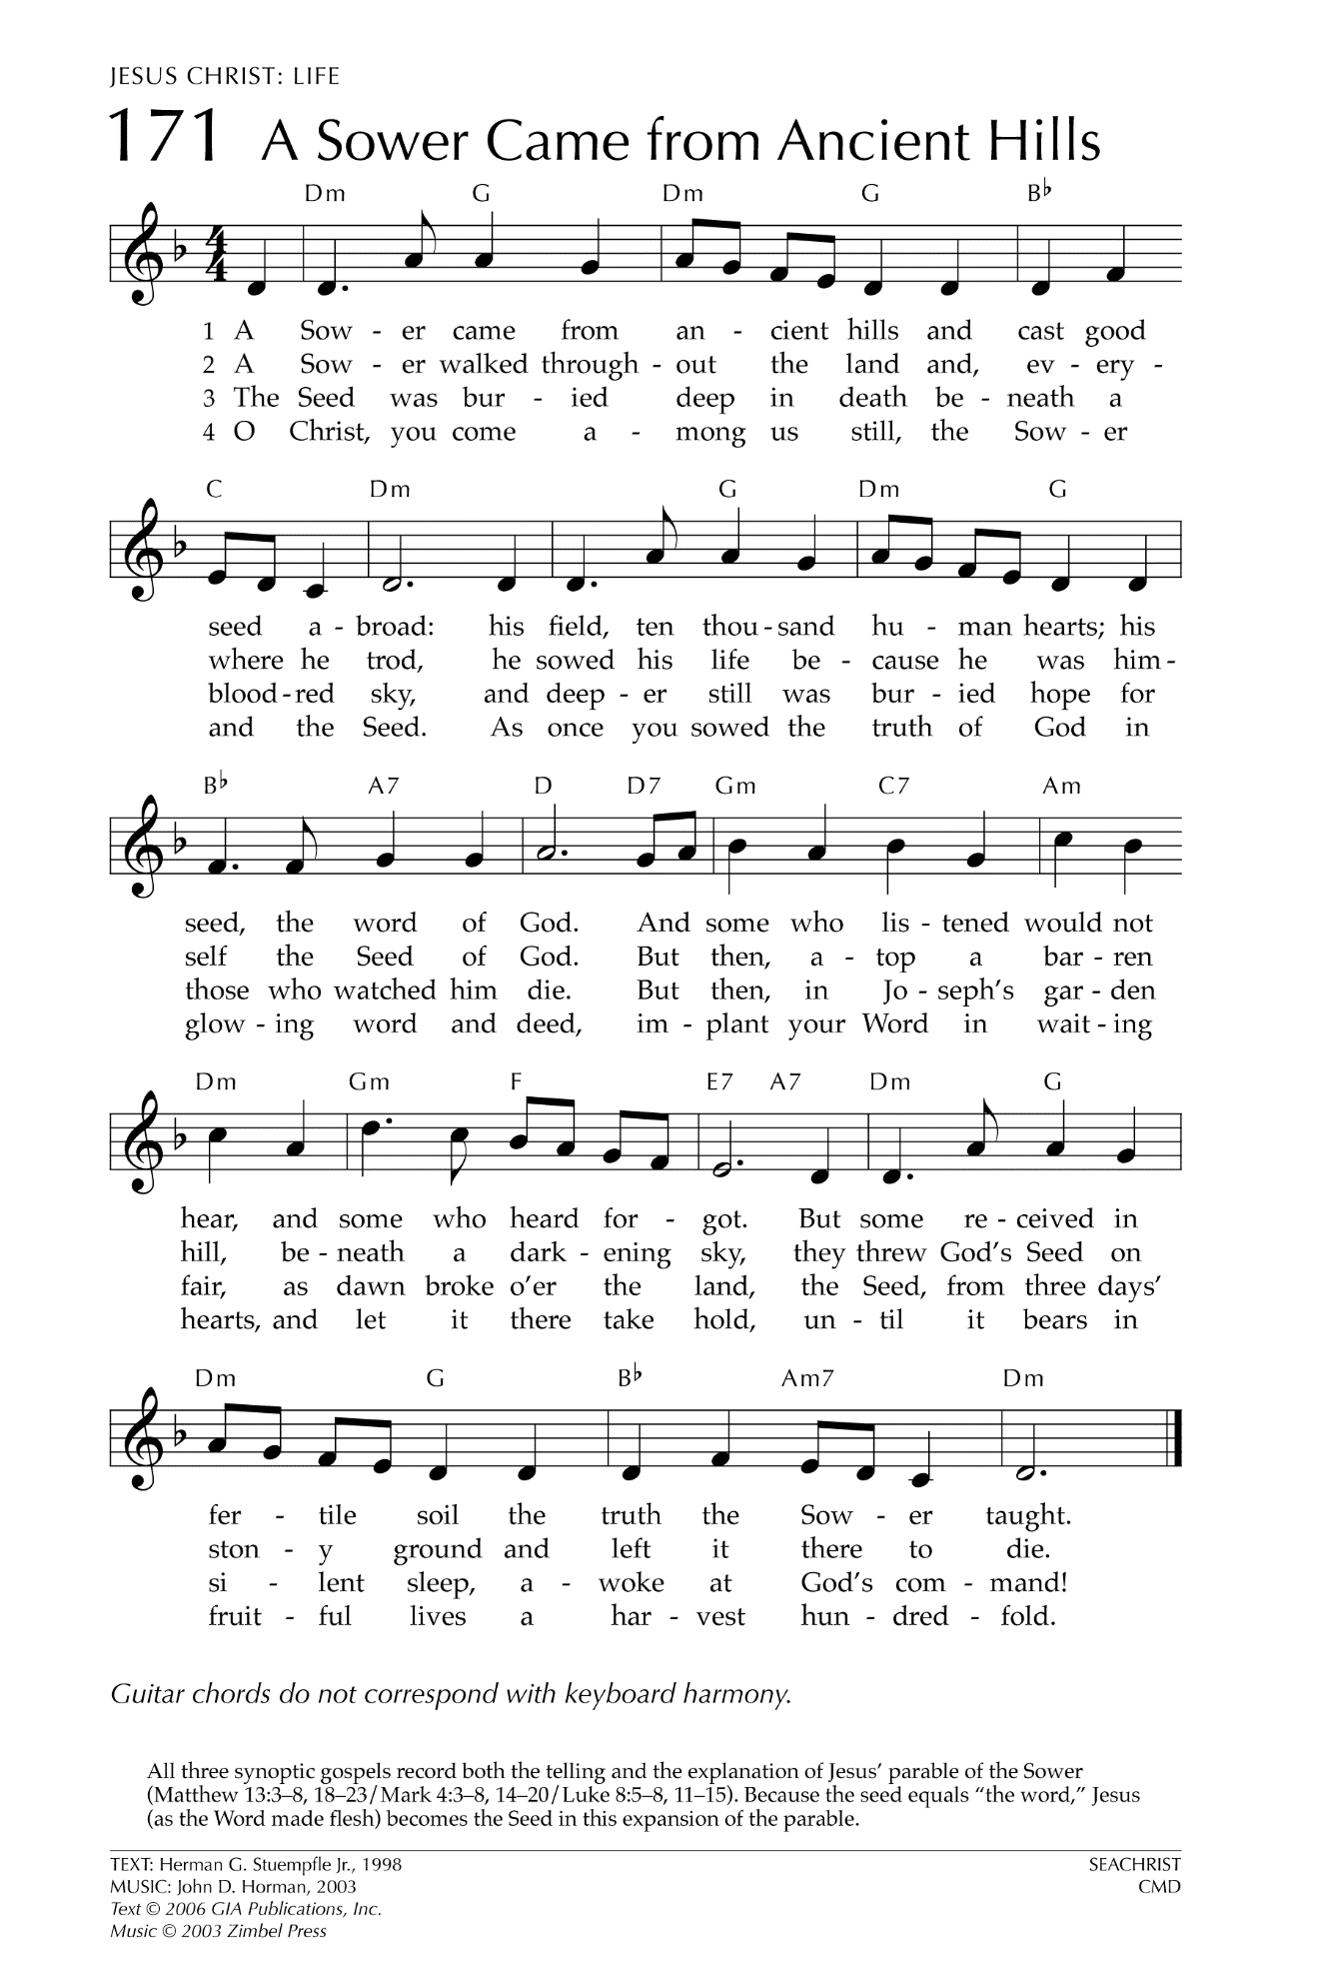
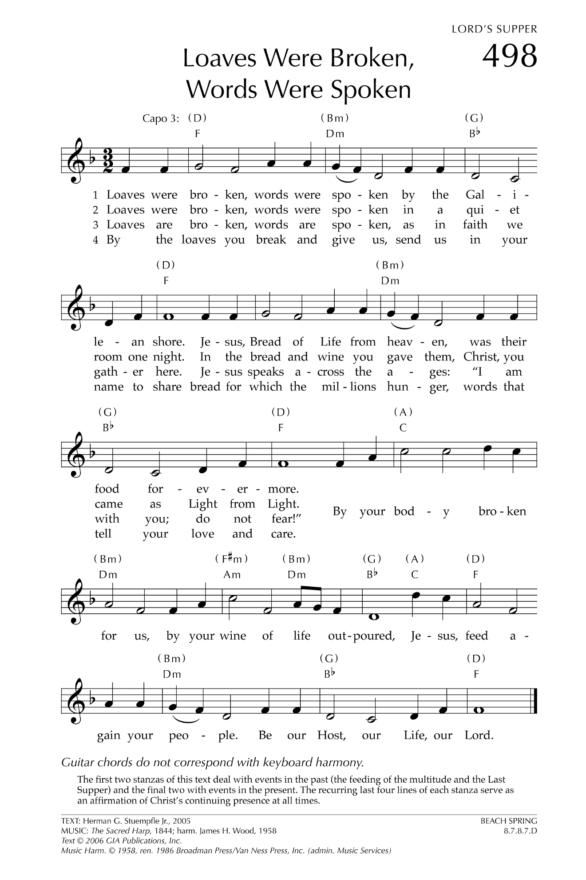
How Great Thou Art

O Lord my God, when I in awesome wonder
Consider all the works thy hands have made,
I see the stars, I hear the rolling thunder,
Thy power throughout the universe displayed:

Then sings my soul, my Savior God, to thee:
How great thou art! How great thou art!
Then sings my soul, my Savior God, to thee:
How great thou art! How great thou art!

When through the woods and forest glades I wander
I hear the birds sing sweetly in the trees,
When I look down from lofty mountain grandeur,
And hear the brook and feel the gentle breeze:

Then sings my soul, my Savior God, to thee:
How great thou art! How great thou art!
Then sings my soul, my Savior God, to thee:
How great thou art! How great thou art!

But when I think that God, his Son not sparing,
Sent him to die, I scarce can take it in,
That on the cross, my burden gladly bearing,
He bled and died to take away my sin.

Then sings my soul, my Savior God, to thee:
How great thou art! How great thou art!
Then sings my soul, my Savior God, to thee:
How great thou art! How great thou art!

When Christ shall come with shout of acclamation
And take me home, what joy shall fill my heart!
Then I shall bow in humble adoration,
And there proclaim, “My God, how great thou art!”

Let There Be Peace on Earth

Let there be peace on earth
And let it begin with me
Let there be peace on earth
The peace that was meant to be
With God as our Father
Christians all are we
Let us walk with each other
In perfect harmony.
Let peace begin with me
Let this be the moment now.
With every step I take
Let this be my solemn vow
To take each moment and live
Each moment in peace eternally
Let there be Peace on Earth
And let it begin with me!

