The Holy Way Presbyterian Church
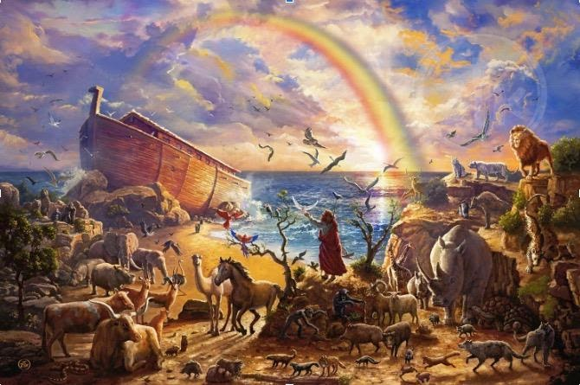

Tucson, Arizona
June 13, 2021 9:30 a.m.
In The Beginning God Created…

Meditation: Noah found grace in the eyes of the Lord because he was a person of faithfulness and integrity. God’s Grace generates faithfulness and integrity, not the other way around.

Welcome to Worship Rev. Tina Salvaneschi
Opening Prayer

Introit: For The Beauty Of The Earth (Hymn 14, V4)
Ryan Phillips, Director of Music

Hymn: We Walk By Faith And Not By Sight (Hymn 817)
Ryan Phillips, Director of Music

Call to Worship: Stephen Levine, Lay Leader

Leader: We gather to worship the One who crafted creation out of chaos,
People: our cries of joy join the anthems of the universe.

Leader: We gather to lift our praise to the God who gives us voice,
People: we bring the songs which have echoed in our hearts all week long.

Leader: We gather as the children of God, our joy unbroken in God's love.
People: young and old, tone deaf and perfect-pitched,
lift the new, new songs of faith.

People: Amen

Prayers for the People Rev. Tina Salvaneschi
& The Lord’s Prayer

Our Father, who art in heaven, hallowed be thy name. Thy kingdom come, thy will be done on earth as it is in heaven. Give us this day our daily bread, and forgive us our debts as we forgive our debtors. And lead us not into temptation, but deliver us from evil, for thine is the kingdom and the power and the glory forever. Amen

Anthem: He Is My All Ryan Phillips, Director of Music

Invitation for Tithes and Offering: Rev. Tina Salvaneschi

Offertory Music: Dr. Astrid Chan
(offering baskets available at all four exits as you leave)

Scripture Reading: Genesis 6:5-8, 17-22, Stephen Levine, Lay Leader
5 Then the Lord saw that the wickedness of man was great in the earth, and that every intent of the thoughts of his heart was only evil continually. 6 And the Lord was sorry that He had made man on the earth, and He was grieved in His heart. 7 So the Lord said, “I will destroy man whom I have created from the face of the earth, both man and beast, creeping thing and birds of the air, for I am sorry that I have made them.” 8 But Noah found grace in the eyes of the Lord.13 And God said to Noah…14 Make yourself an ark…
17And behold, I Myself am bringing floodwaters on the earth, to destroy from under heaven all flesh in which is the breath of life; everything that is on the earth shall die. 18 But I will establish My covenant with you; and you shall go into the ark—you, your sons, your wife, and your sons’ wives with you. 19 And of every living thing of all flesh you shall bring two of every sort into the ark, to keep them alive with you; they shall be male and female. 20 Of the birds after their kind, of animals after their kind, and of every creeping thing of the earth after its kind, two of every kind will come to you to keep them alive. 21 And you shall take for yourself of all food that is eaten, and you shall gather it to yourself; and it shall be food for you and for them.” 22 Thus Noah did; according to all that God commanded him, so he did.
Leader: This is the Word of the Lord. People: Thanks be to God.
and Creation: The Flood
Rev. Tina Salvaneschi
Sending Hymn: May God Support You All Your Days (Hymn 548)
Ryan Phillips, Director of Music

Benediction: 2 Corinthians 13:14 Rev. Tina Salvaneschi

Song: Let There Be Peace on Earth Ryan Phillips, Director of Music
Postlude: Dr. Astrid Chan

What’s New At the Holy Way?

“Sermon Debrief Bible Study” - Tuesday 10:00 a.m. Zoom
Come dive deeper into Sunday’s sermon and study the history, context, signs and meaning of God’s Word and how the Scriptures can apply to our lives today. This is lead by Pastor Tina and is very interactive!

“Thoughtful Thursdays” - Thursday 10:00 a.m. Zoom
This is a great way to stay connected (especially for our snowbirds, and folks that can’t make it to in-person services!). We share about our lives, spend time talking, share joys, pray requests…and anything else that comes up. Oh yes, laughter seems to happen too. This is group lead, with Pastor Tina and for women AND men!

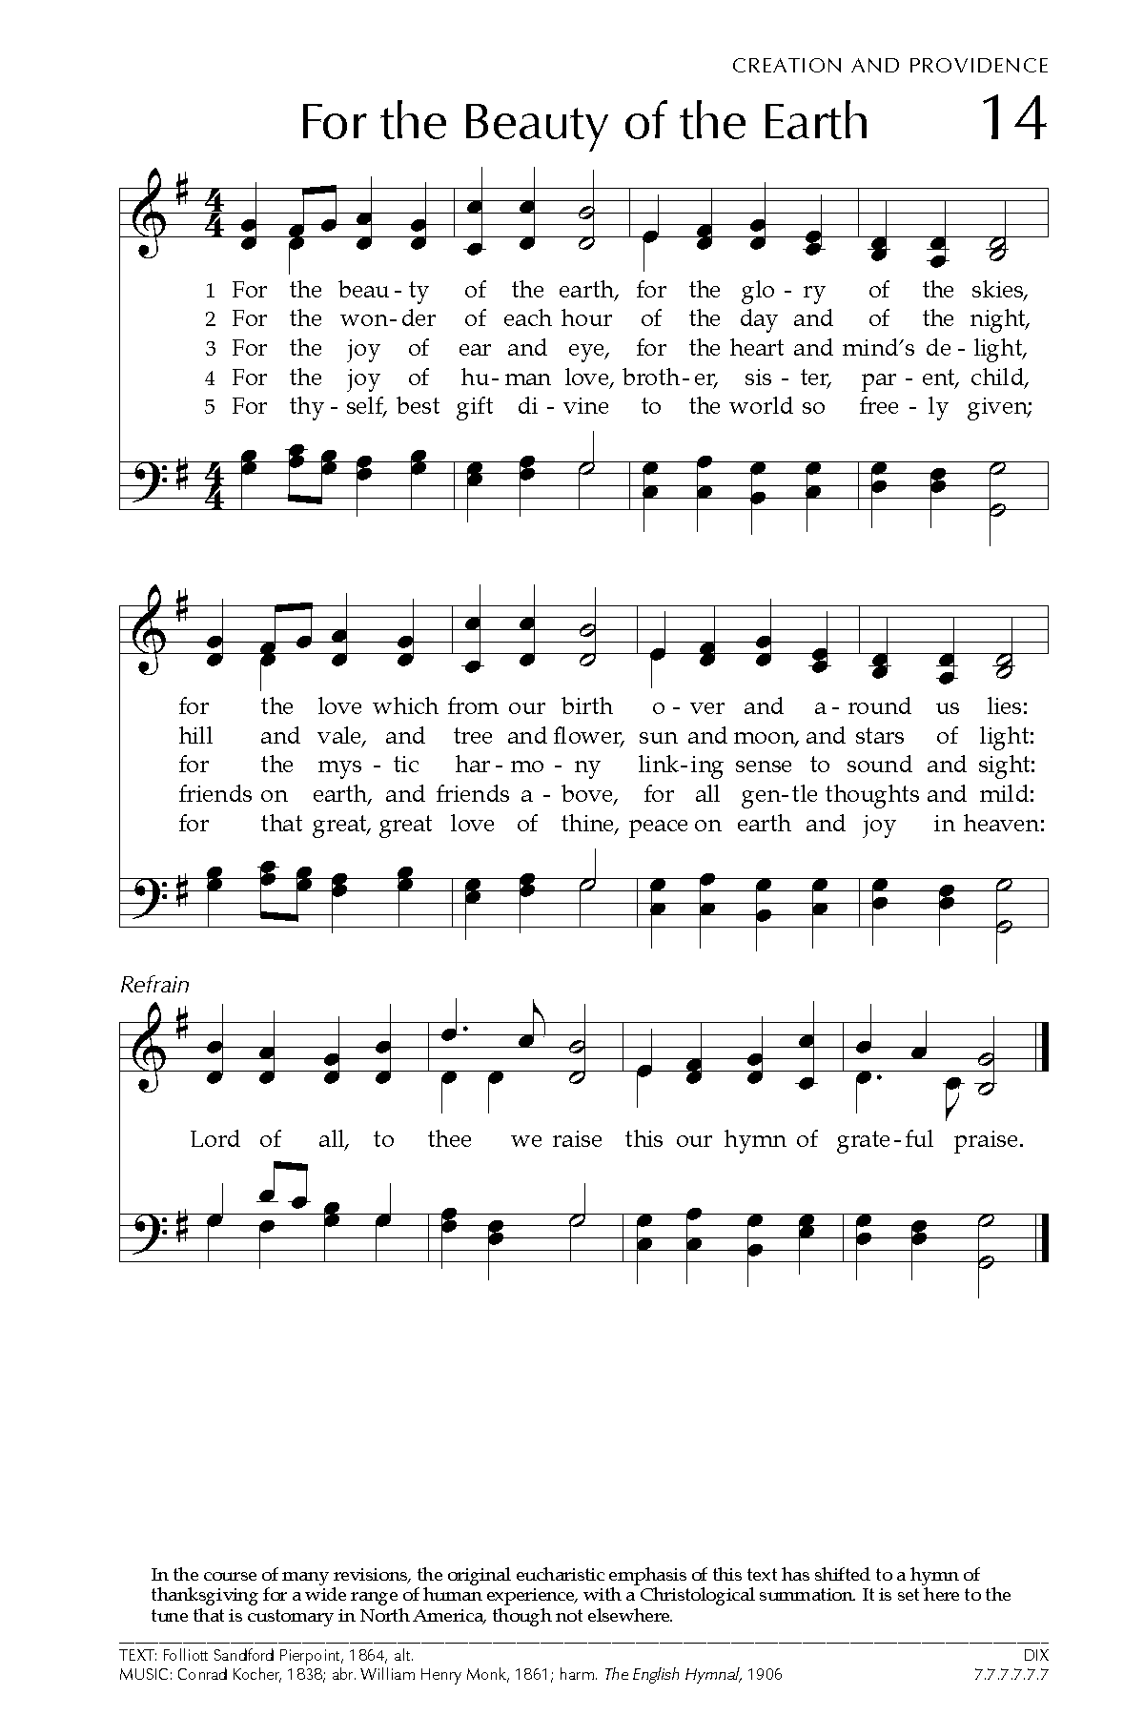
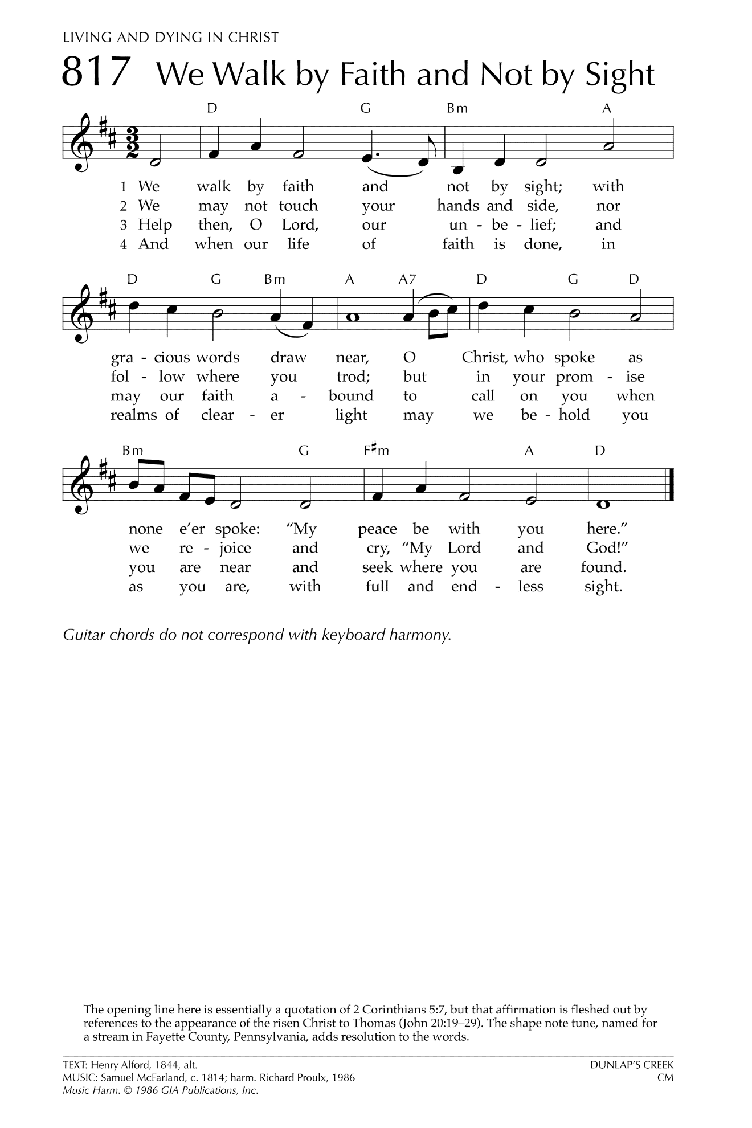
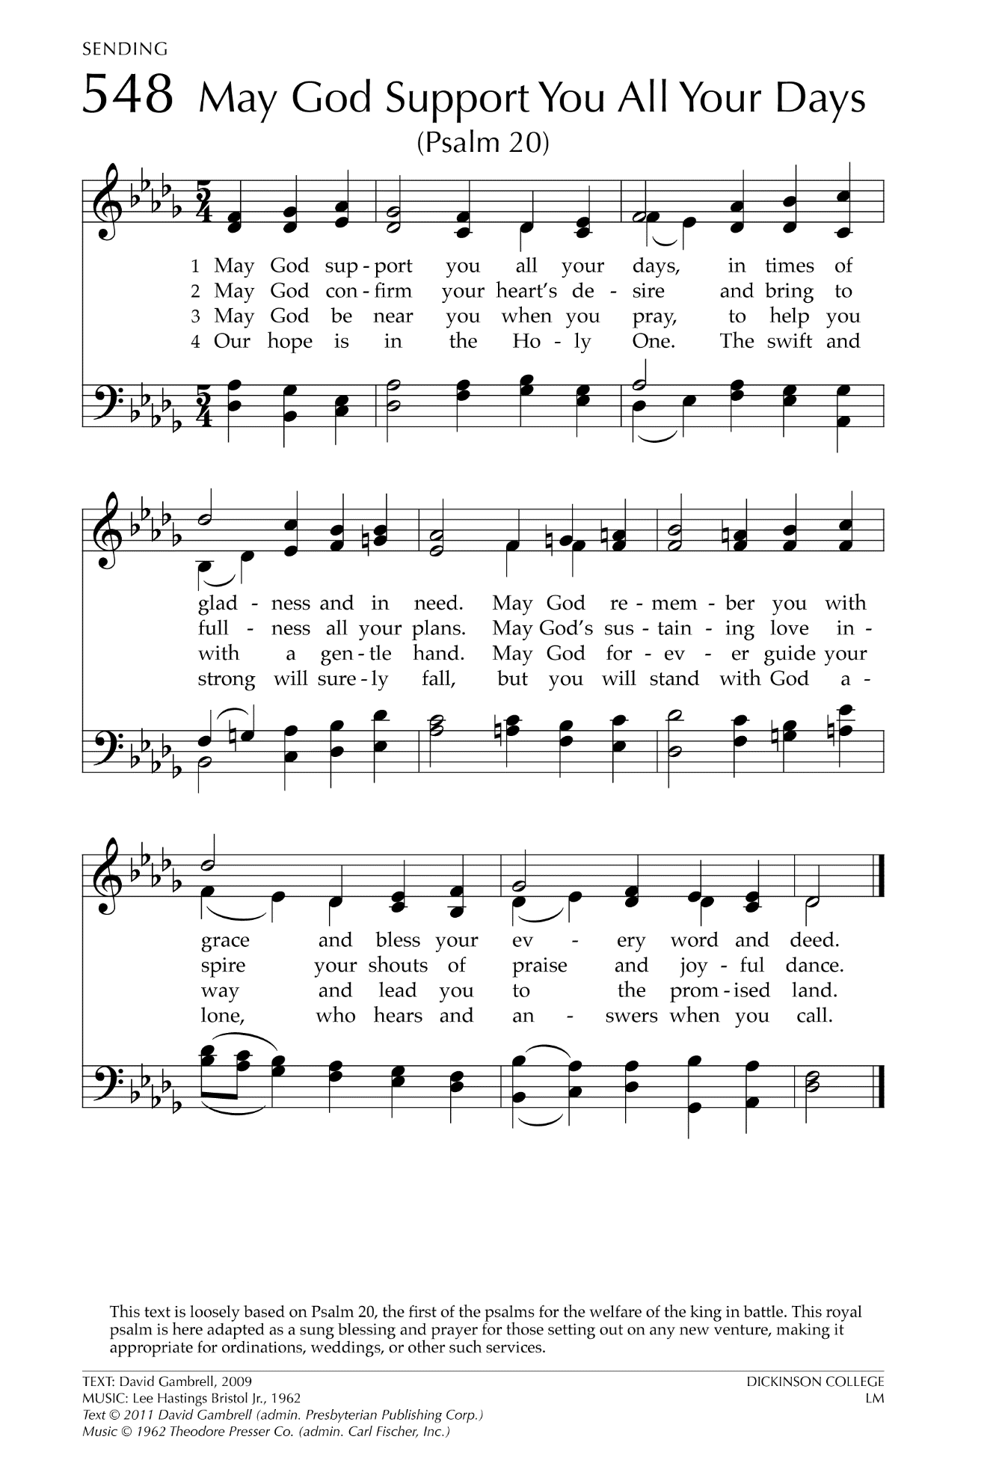

Let There Be Peace on Earth

Let there be peace on earth
And let it begin with me
Let there be peace on earth
The peace that was meant to be
With God as our Father
Christians all are we
Let us walk with each other
In perfect harmony.
Let peace begin with me
Let this be the moment now.
With every step I take
Let this be my solemn vow
To take each moment and live
Each moment in peace eternally
Let there be Peace on Earth
And let it begin with me!

